Attempt 2

All questions

Top of Form

Question 1: **Correct**

**Dimensions containing ____________ and ____________  values cannot be continuous.**

* 

**Boolean**

**(Correct)**

* 

**Date**

* 

**String**

**(Correct)**

* 

**Date and Time**

**Explanation**

**According to Tableau's official documentation -**

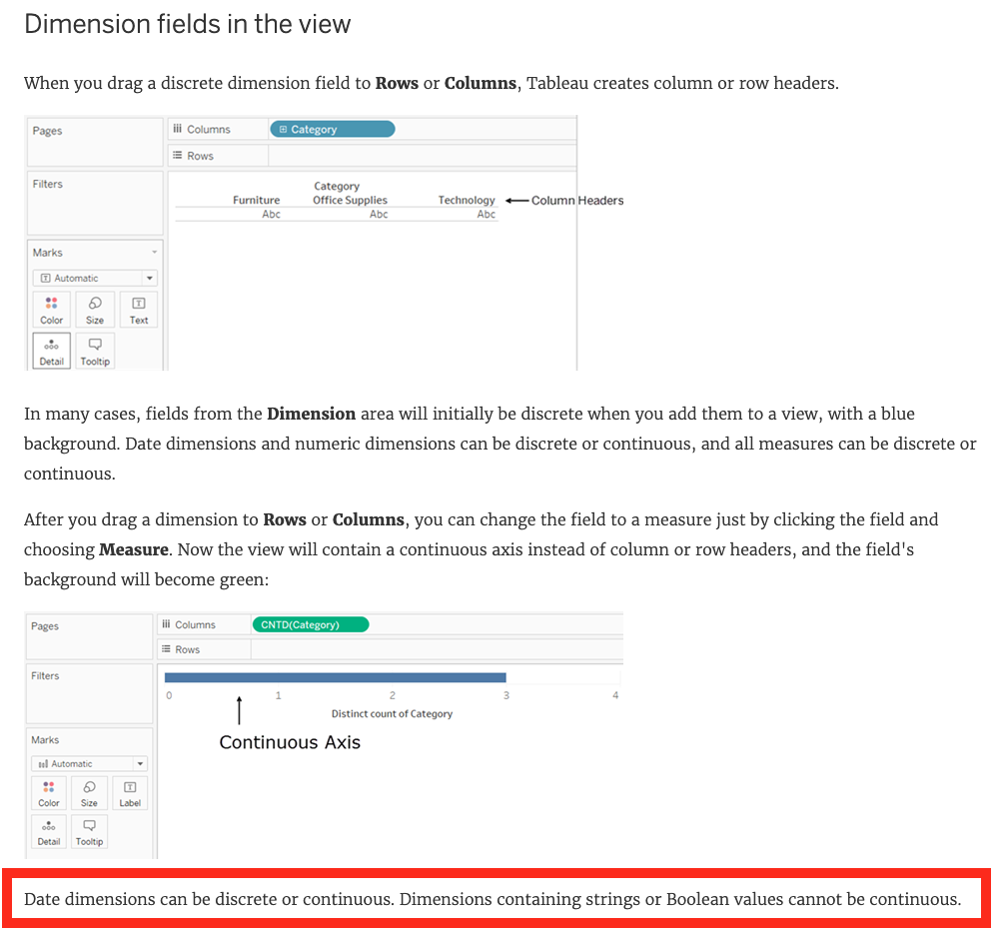

**Reference:**<https://help.tableau.com/current/pro/desktop/en-us/datafields_typesandroles.htm>

Bottom of Form

Top of Form

Question 2: **Correct**

**True or False: It is possible to add a field to more than one hierarchy**

* 

**True**

**(Correct)**

* 

**False**

**Explanation**

Yes! It is possible to duplicate a field and add it to more than one hierarchy. Right click and choose duplicate.

**Reference**: <https://www.tableau.com/about/blog/2016/8/take-note-these-10-handy-tableau-shortcuts-57561>

Bottom of Form

Top of Form

Question 3: **Correct**

**Most viewers scan content starting at the _____________ of a page.**

* 

**top left**

**(Correct)**

* 

**center**

* 

**top right**

* 

**bottom right**

* 

**bottom left**

**Explanation**

**According to Tableau's official documentation:**

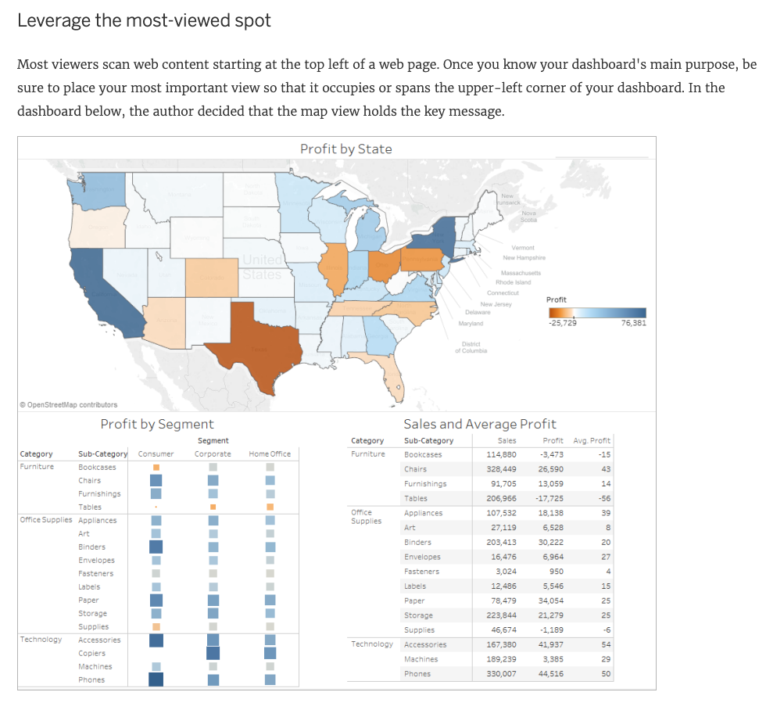

**Reference:**<https://help.tableau.com/current/pro/desktop/en-us/dashboards_best_practices.htm>

Bottom of Form

Top of Form

Question 4: **Correct**

**Relationships are represented by __________________ and operate at the ____________________.**

* 

**noodles, physical layer**

* 

**Venn diagrams, logical layer**

* 

**Venn diagrams, physical layer**

* 

**noodles, logical layer**

**(Correct)**

**Explanation**

**From the official documentation:**

The default view that you first see in the Data Source page canvas is the **logical layer** of the data source. You combine data in the logical layer using relationships (or noodles).

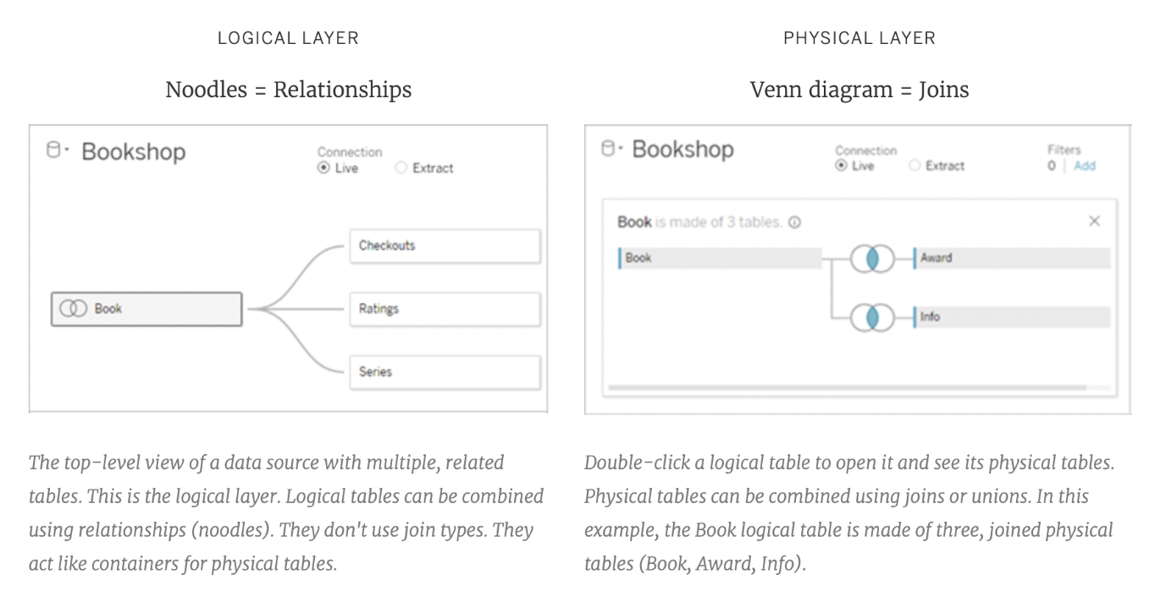

**Reference:**<https://help.tableau.com/current/server/en-us/datasource_datamodel.htm>

Bottom of Form

Top of Form

Question 5: **Correct**

**When you want to first apply a filter and THEN show the Top N or Bottom N elements, which of the following filters would you use?**

* 

**None of the these**

* 

**Extract Filter**

* 

**Data source Filter**

* 

**Context Filter**

**(Correct)**

**Explanation**

**IMPORTANT QUESTION, PAY ATTENTION**

By default, all filters that you set in Tableau are computed **independently**. That is, each filter accesses all rows in your data source without regard to other filters. However, you can set one or more categorical filters as context filters for the view. You can think of a context filter as being an **independent** filter. Any other filters that you set are defined as dependent filters because they process only the data that passes through the context filter.

You may create a context filter to:

**1) Improve performance** – If you set a lot of filters or have a large data source, the queries can be slow. You can set one or more context filters to improve performance.

**2) Create a dependent numerical or top N filter – You can set a context filter to include only the data of interest, and then set a numerical or a top N filter.**

**Reference:**<https://help.tableau.com/current/pro/desktop/en-us/filtering_context.htm>

Bottom of Form

Top of Form

Question 6: **Correct**

**Is SUM a table calculation?**

* 

**Yes**

* 

**No**

**(Correct)**

**Explanation**

SUM is an **aggregate function**, not a table calculation!

A table calculation is a transformation you apply to the values in a visualization. Table calculations are a special type of calculated field that computes on the **local** data in Tableau. They are calculated based on what is currently in the visualization and do not consider any measures or dimensions that are filtered out of the visualization.

**The most common Table calculations are:**

Running Total

Percent Difference

Difference

Percent of Total

Rank

Percentile

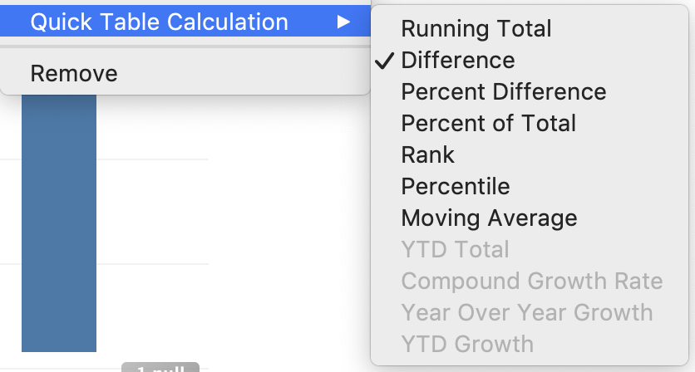

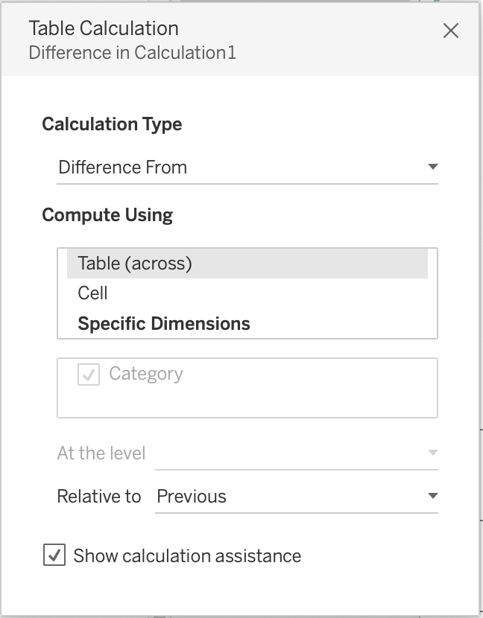

These can be calculated using : Table(across), Cell, or Specific dimensions!

**Reference:**<https://help.tableau.com/current/pro/desktop/en-us/calculations_tablecalculations_definebasic_runningtotal.htm>

Bottom of Form

Top of Form

Question 7: **Correct**

**Which of the following are valid objects when creating a dashboard in Tableau? Choose 4.**

* 

**Text**

**(Correct)**

* 

**Extension**

**(Correct)**

* 

**Web Page**

**(Correct)**

* 

**Video**

* 

**Image**

**(Correct)**

**Explanation**

Video is **NOT** a valid object type while creating dashboards in Tableau! All others are valid object types.

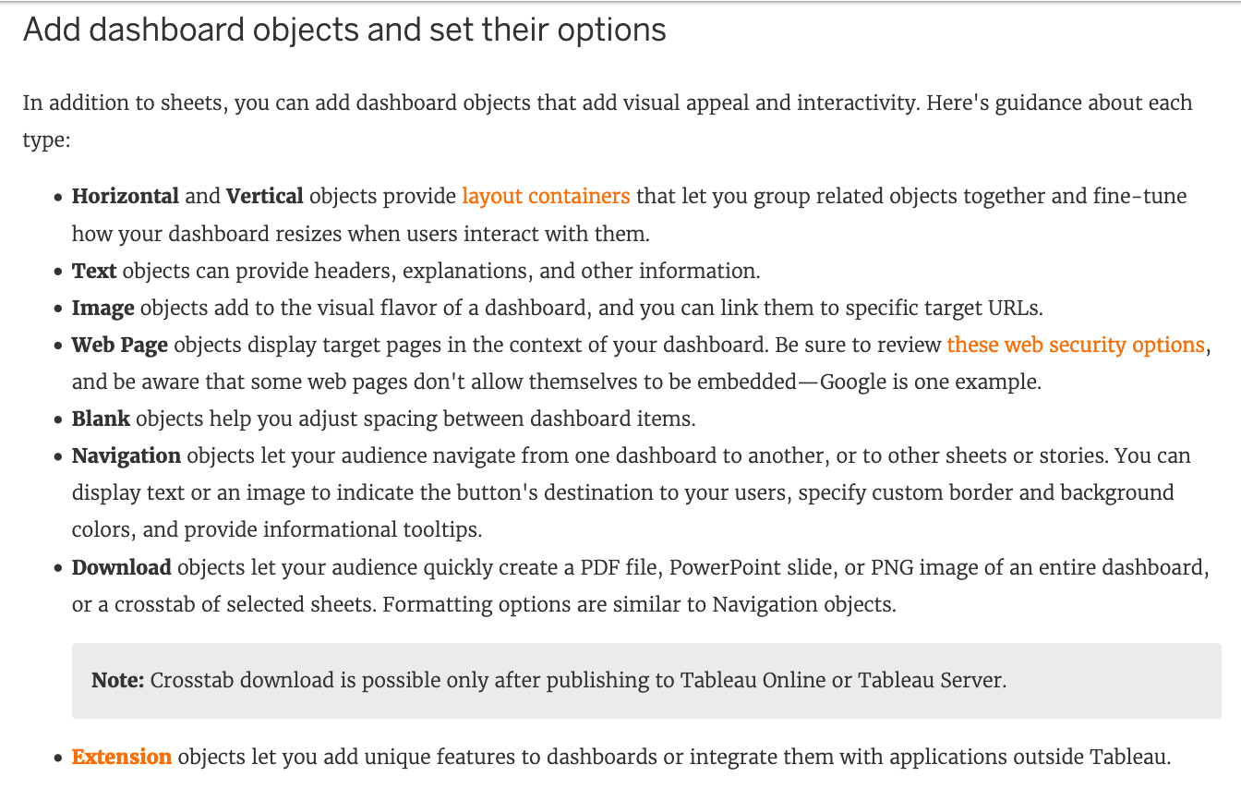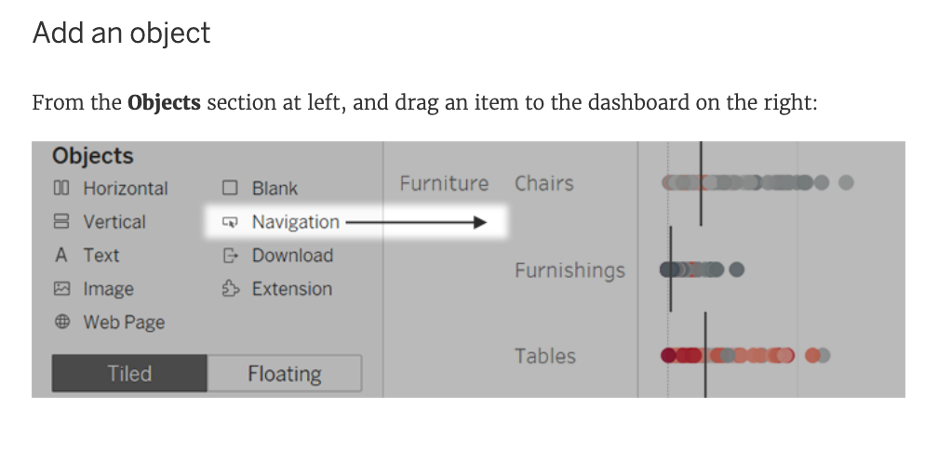

**Reference:** <https://help.tableau.com/current/pro/desktop/en-us/dashboards_create.htm>

Bottom of Form

Top of Form

Question 8: **Correct**

**Which of the following shapes does a Heat Map use by default?**

* 

**Text**

* 

**Line**

* 

**Square**

**(Correct)**

* 

**Circle**

**Explanation**

By default, the shape that a Heap map uses is a **"Square".** See below:

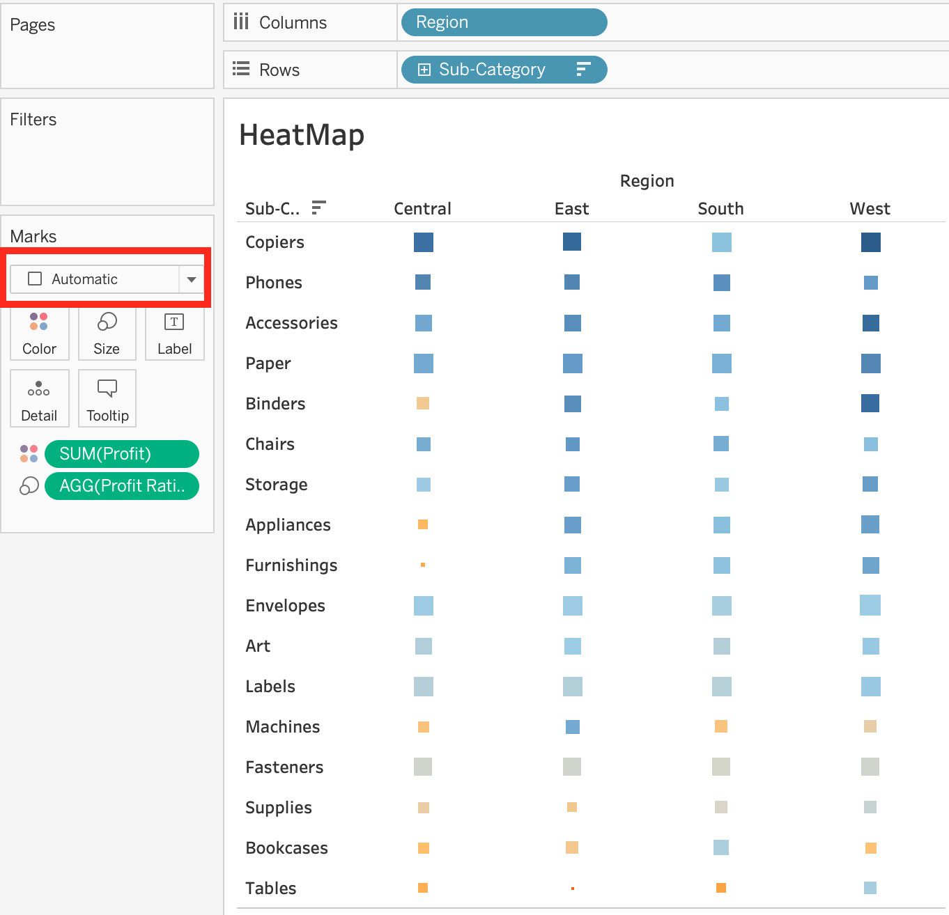

**Reference:**<https://help.tableau.com/current/pro/desktop/en-us/buildexamples_highlight.htm>

Bottom of Form

Top of Form

Question 9: **Correct**

**Is it possible to add both a Dashboard and a Worksheet at the same time to a Story Point in Tableau?**

* 

**No**

**(Correct)**

* 

**Yes**

**Explanation**

This is a tricky question. We are talking about story **POINTS**, and not entire stories in the question.

To create a story, lets say I have a blank story with 1 dashboard and 1 worksheet.

I can simply drag the dashboard into the view to create a new story point.

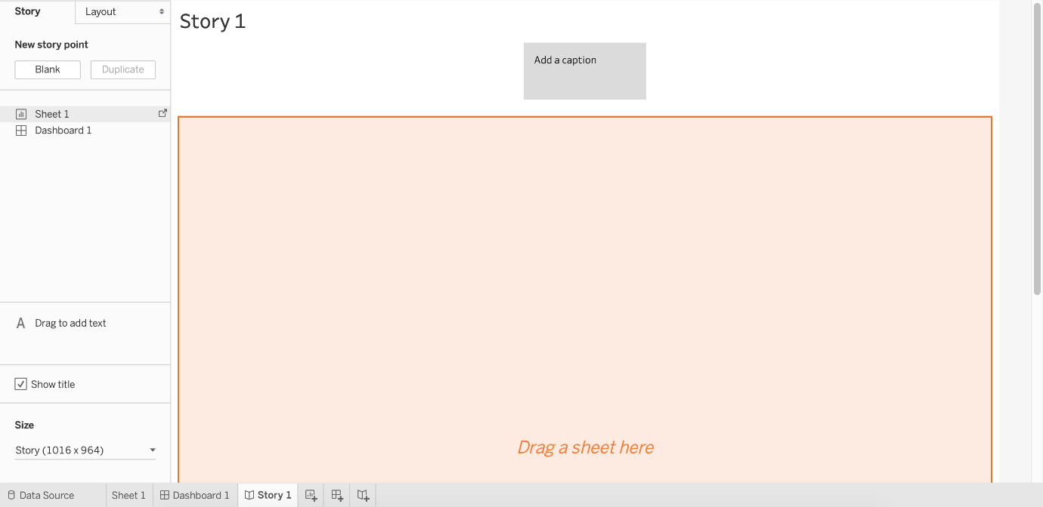

Now, if I try to adjust the worksheet beside it in this same view, I cannot. See below:

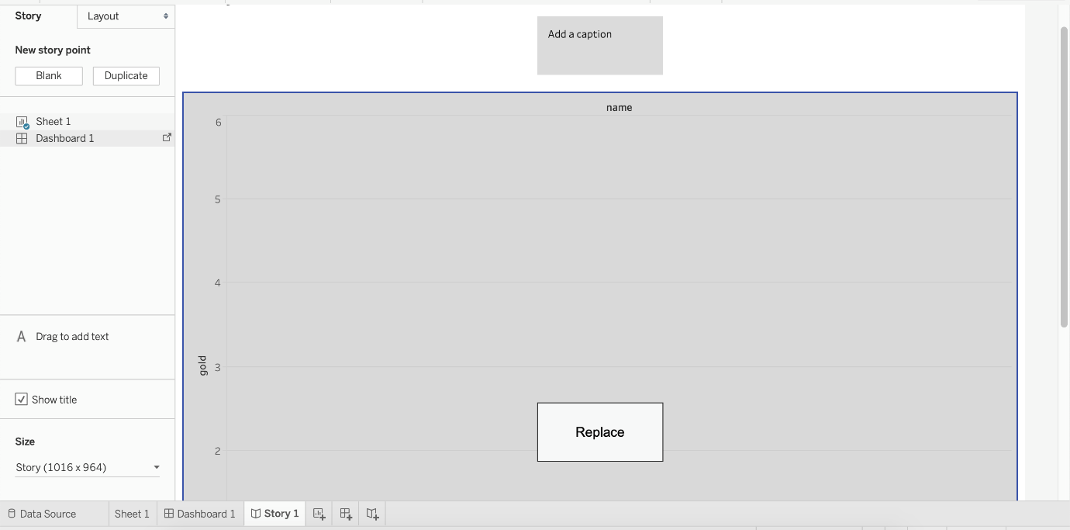

The only option available is to replace the existing view. Therefore, the answer is NO since they both cannot be added.

**Read more about stories in Tableau:**<https://help.tableau.com/current/pro/desktop/en-us/story_create.htm>

Bottom of Form

Top of Form

Question 10: **Correct**

**As a general best practice, how many categories can a pie chart display effectively?**

* 

**3 to 5**

* 

**2 to 5**

**(Correct)**

* 

**3 to 7**

* 

**2 to 8**

**Explanation**

As a general best practice, your pie chart should contain **2 to 5** categories. Anything more than that is not easy for the eyes to distinguish. This is a common question and mentioned in Tableau's own eLearning module as well!

**See how to build a pie chart:**



**Reference:** <https://help.tableau.com/current/pro/desktop/en-us/buildexamples_pie.htm>

Bottom of Form

Top of Form

Question 11: **Correct**

**True or False: It is not possible to blend axes for multiple measures into a single axis**

* 

**False**

**(Correct)**

* 

**True**

**Explanation**

We can very much blend multiple measures into a single axis. Such charts are called Combined-Axis / Blended-Axis charts. Follow along:

Measures can share a single axis so that all the marks are shown in a single pane. To blend multiple measures, drag one measure or axis and drop it onto an existing axis.



Instead of adding rows and columns to the view, when you blend measures there is a single row or column and all of the values for each measure is shown along one continuous axis. For example, the view below shows quarterly sales and profit on a shared axis.

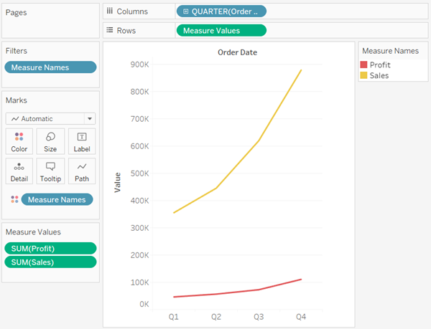

**Note:** If you drag a measure on to the canvas and only see a **single** ruler indicator instead of the double ruler indicator shown below, Tableau creates **dual axes** instead of a blended axis. For more information about how to create dual axes, see [Compare two measures using dual axes](https://help.tableau.com/current/pro/desktop/en-us/multiple_measures.htm#Dual).

**Reference:** <https://help.tableau.com/current/pro/desktop/en-us/multiple_measures.htm>

Bottom of Form

Top of Form

Question 12: **Correct**

**You just added this field to the Columns shelf.**

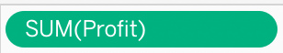

**What will this create?**

* 

**A horizontal axis**

**(Correct)**

* 

**A horizontal header**

* 

**A vertical header**

* 

**A vertical axis**

**Explanation**

This question can be confusing for many students, so in such cases it's always best to practically try the question out in Tableau. We know that continuous fields will always create an axis, so options stating 'header' are automatically eliminated. For our question, see below:

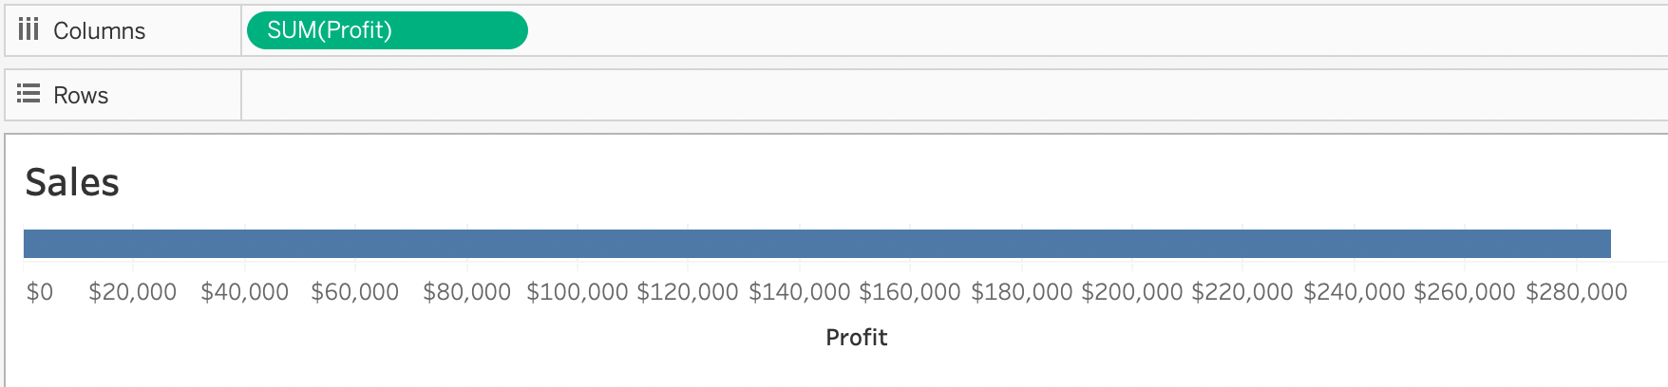

**Had the question asked us to place this pill on the Rows shelf instead, we would've gotten a different answer:**

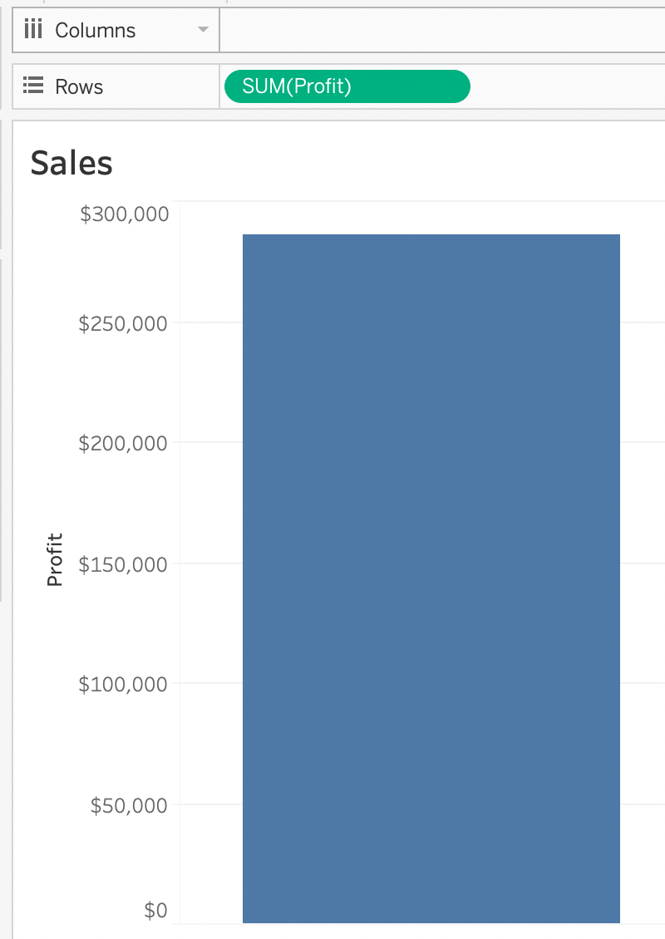

Bottom of Form

Top of Form

Question 13: **Correct**

**True or False: We get different colour pallete options if we drop a discrete field on "Color" in the marks card compared to if we drop a continous field on Color.**

* 

**False**

* 

**True**

**(Correct)**

**Explanation**

Yes! We get different color palettes. They are:

**\*From the official Tableau documentation\***

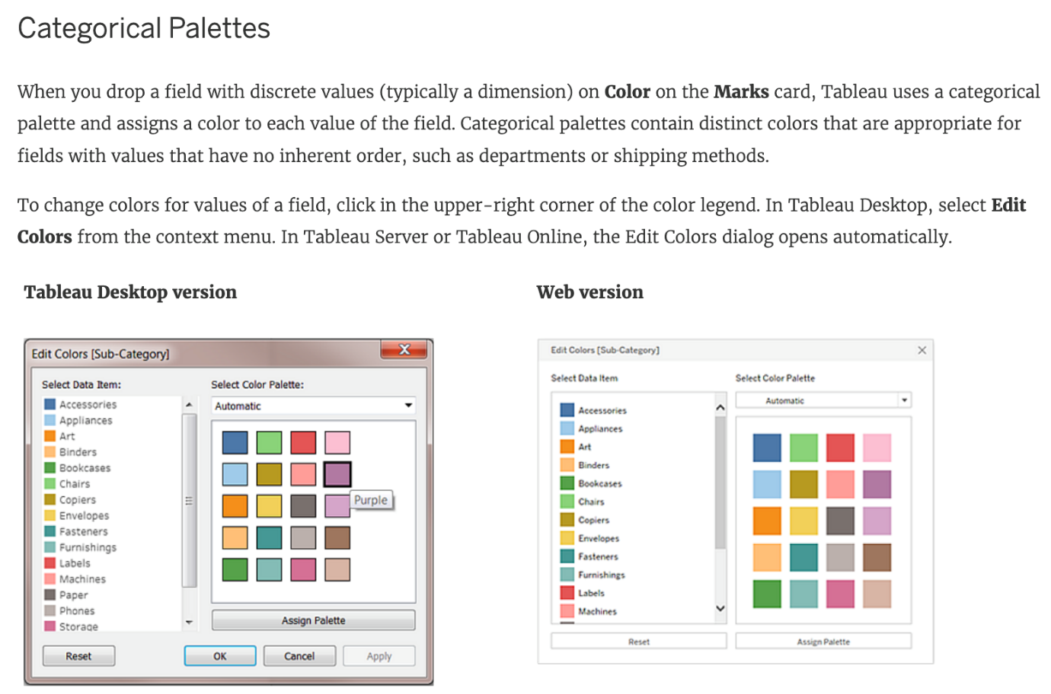

**To change the color for a value**

1) Click on an item on the left, under Select Data Item.

2) Click a new color in the palette on the right. In Tableau Desktop you can hover over a swatch to identify the color.

3) Repeat for as many values that you want to change.

4) In Tableau Desktop, click OK to exit the Edit Colors dialog box. In Tableau Server or Tableau Online, simply close the dialog box.

AND

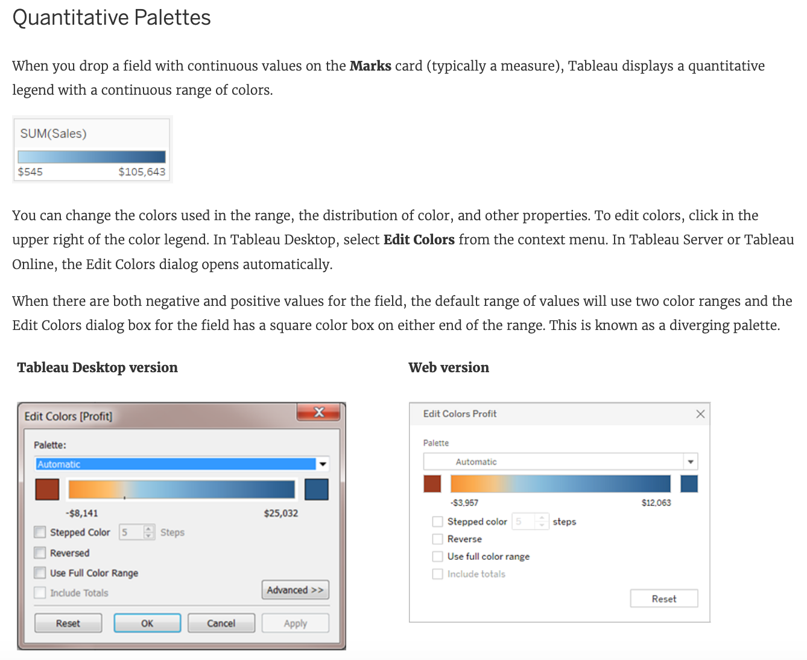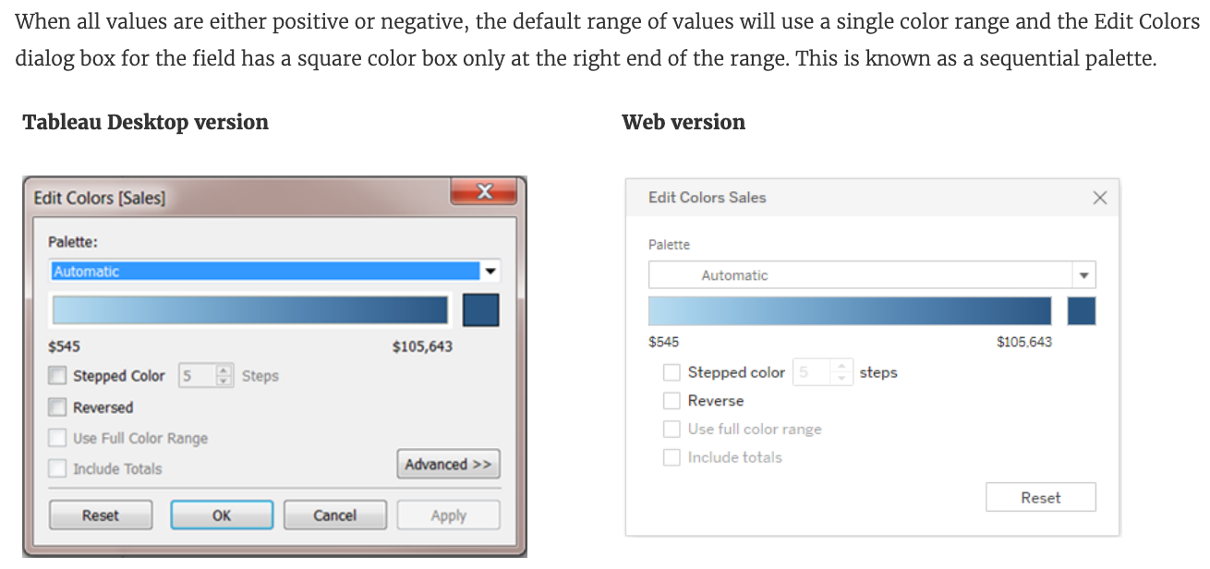

**Reference:** [https://help.tableau.com/current/pro/desktop/en us/viewparts_marks_markproperties_color.htm](https://help.tableau.com/current/pro/desktop/en-us/viewparts_marks_markproperties_color.htm)

Bottom of Form

Top of Form

Question 14: **Correct**

**Tableau auto-generates ____________ dimension(s) and _____________ measure(s) for us**

* 

**1 , 4**

**(Correct)**

* 

**2 , 2**

* 

**2 , 3**

* 

**1 , 2**

**Explanation**

Tableau auto-generates :

**1 Dimension**- Measure Names

**4 Measures** - Latitude, Longitude, Number of records, Measure Values

Starting with Tableau **2020.2**, every table in a data source has a Count field, in the form of *NameofTable*(Count). The table count field is an automatically generated, calculated field. **(THIS IS NOT PRESENT IN VERSION 2020.1 ON WHICH THE EXAM IS CURRENTLY BASED)**

**Reference:**<https://help.tableau.com/current/pro/desktop/en-us/datafields_understanddatawindow.htm>

Bottom of Form

Top of Form

Question 15: **Correct**

**Our use case states that we need to create a set showing the Bottom 10 products by Profit in each Region. Which of the following filter types should you apply on Region?**

* 

**Measure Filters**

* 

**Context Filters**

**(Correct)**

* 

**Extract Filters**

* 

**Dimension Filters**

**Explanation**

The beauty of context filters is that according to Tableau's Order of Operations, they are executed before Sets.

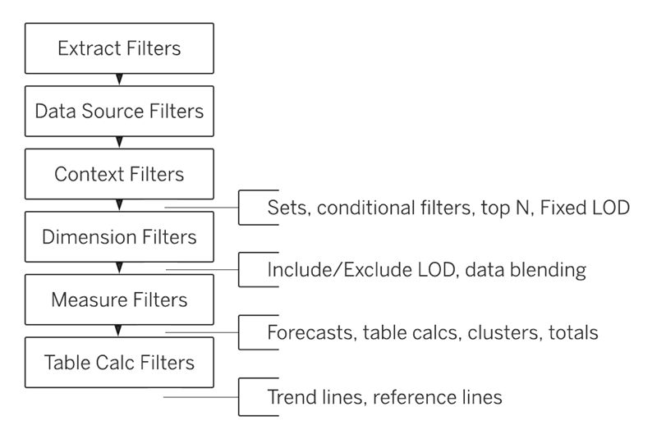

This means that based on what Region's you've selected - Tableau will first only preserve the rows for those Regions. THEN, after this it will compute the Set , i.e , Bottom 10 products in each Region.

**1) First let's create a set to compute the Bottom 10 Products by Profit.**

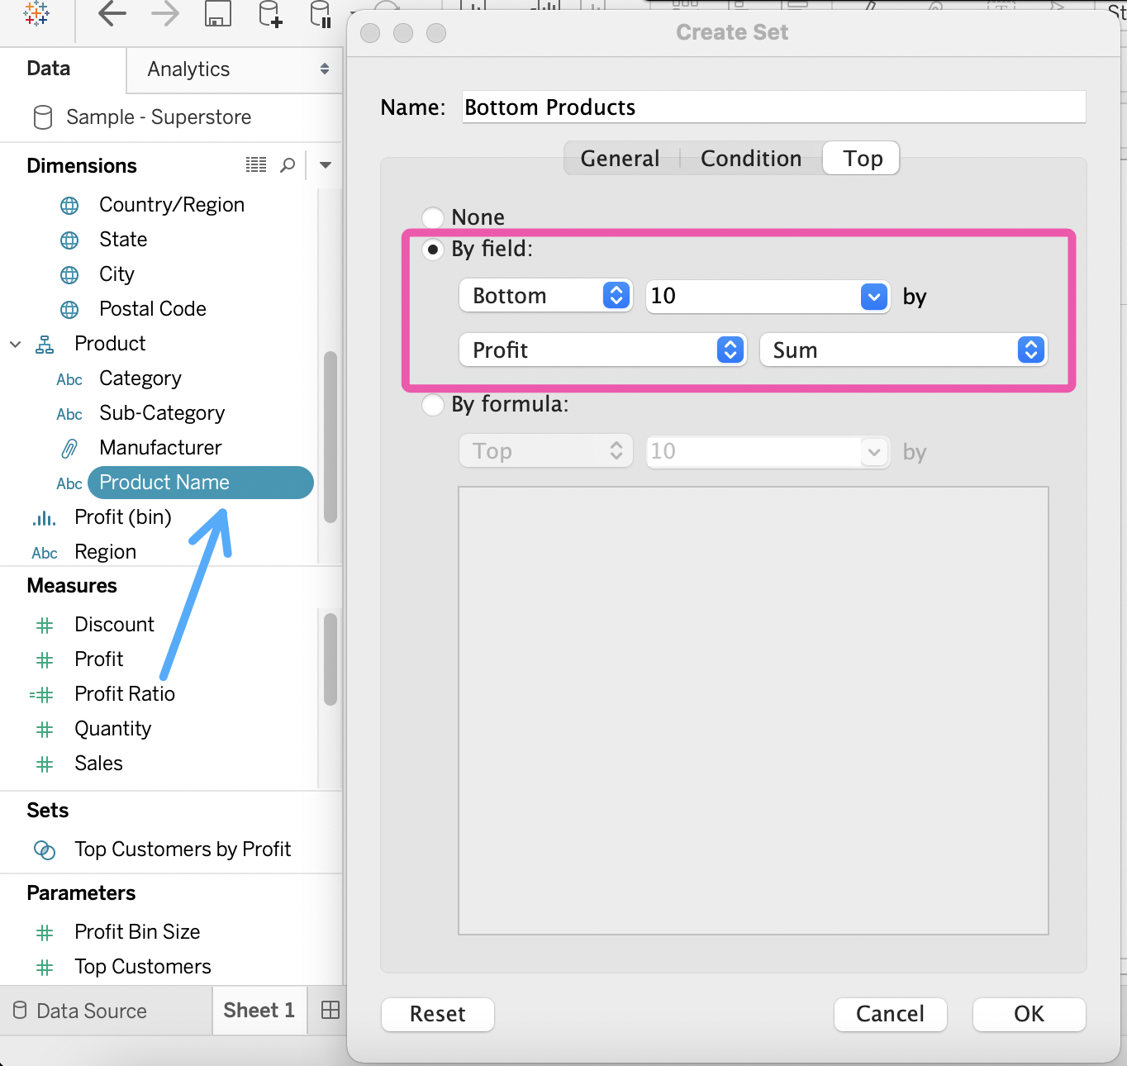

2) Next, take region on the Rows Shelf followed by the Set we just created. Drag Region and the Set to the Filters Shelf as well.

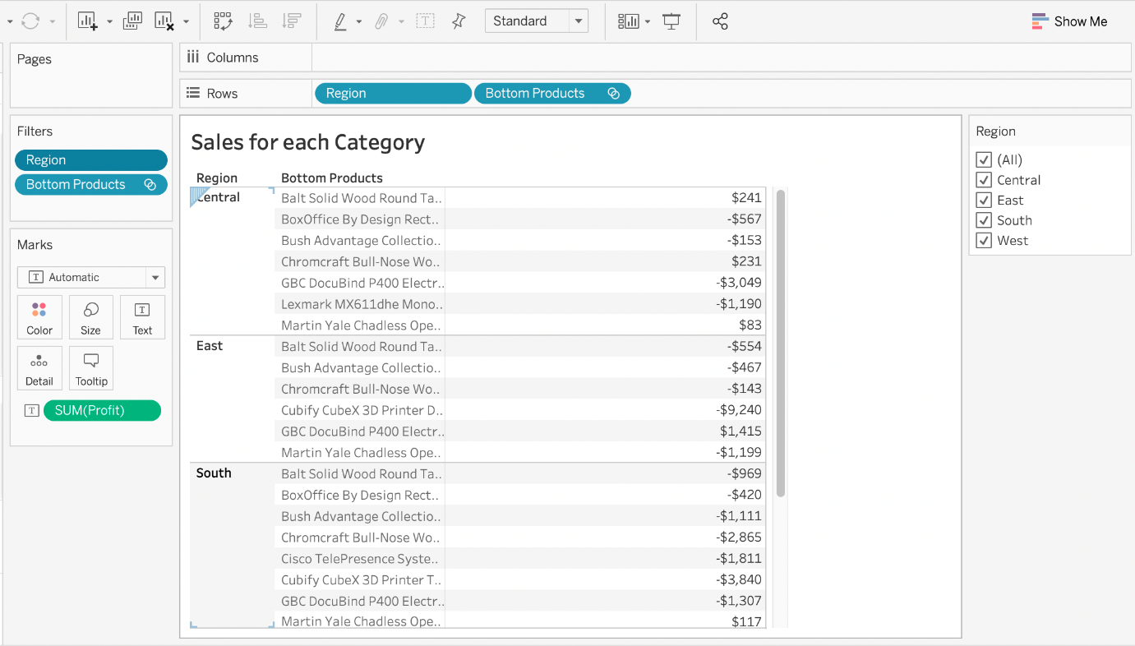

3) Now, try to only visualize the data for the South Region:

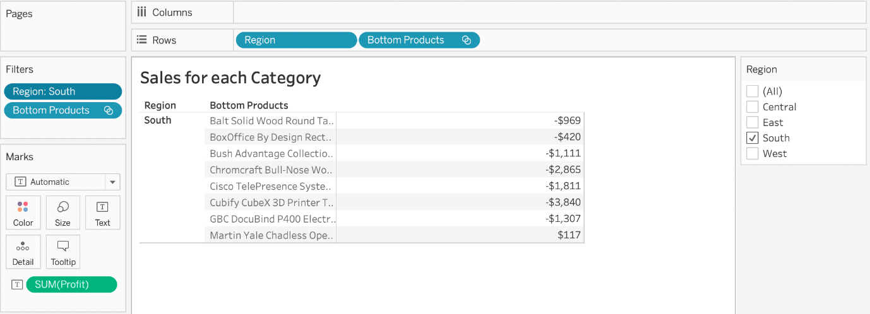

**4) The problem right now is that Tableau is computing the Set first (Bottom 10 Products), and then applying the Dimension Filter - South Region and hence these values are incorrect. Note how these aren't even 10 products, but rather just 8. To fix this, simply add Region to Context:**

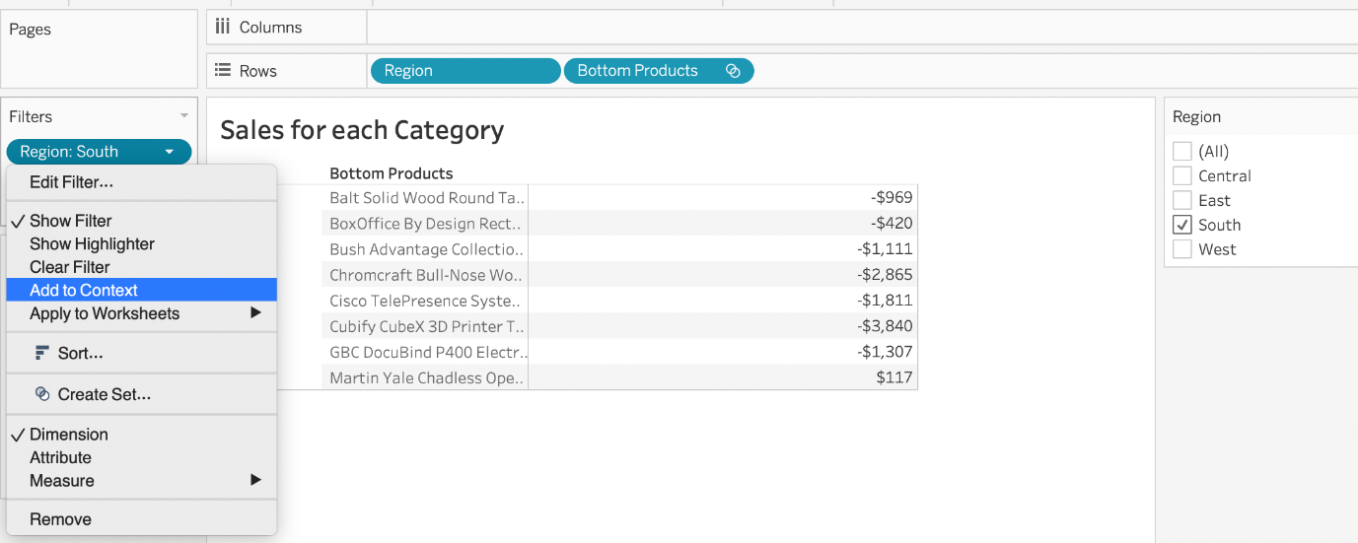

**Upon doing this, we get the correct answer as :**

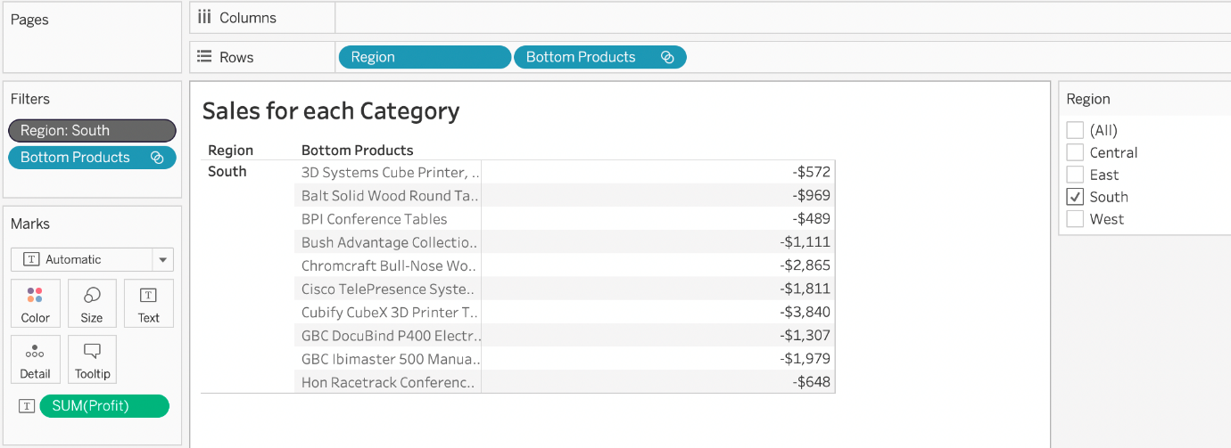

**References:** <https://help.tableau.com/current/pro/desktop/en-us/order_of_operations.htm>

<https://help.tableau.com/current/pro/desktop/en-us/filtering_context.htm>

Bottom of Form

Top of Form

Question 16: **Correct**

**Which of the following is an example of a Date Part?**

* 

**November**

**(Correct)**

* 

**Q4 2017**

* 

**March 2019**

* 

**September 2020**

**Explanation**

All answers except November are examples of Date Values (continuous in nature).

**See below:**

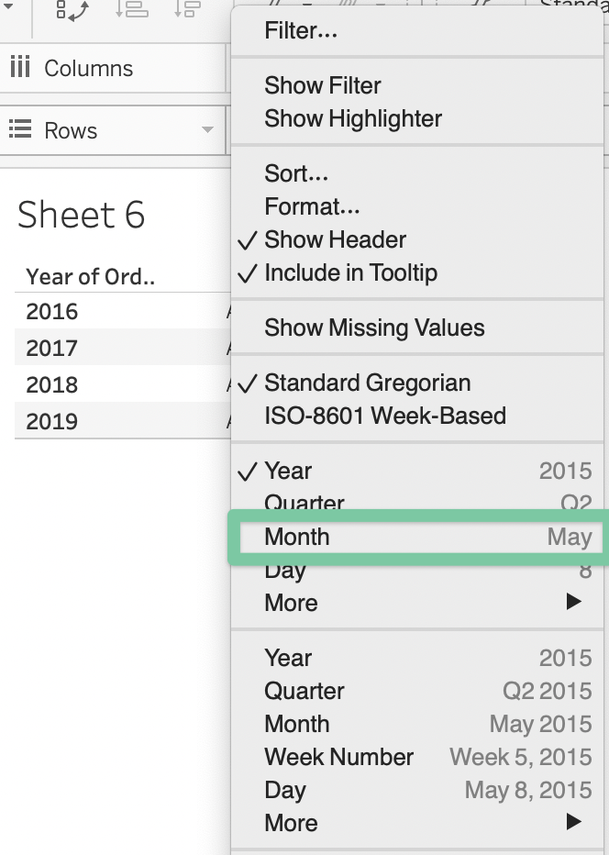

You can see that the option in Green symbolizes our correct answer, i.e only a Month. In our case that month is November (the correct answer).

All other options are combinations **of a year with one other value** (like a month, quarter, or day). So this is how by looking at an option you can know if its a date part or date value!

Bottom of Form

Top of Form

Question 17: **Correct**

**We can join a maximum of ______ tables in Tableau**

* 

**128**

* 

**16**

* 

**64**

* 

**32**

**(Correct)**

**Explanation**

It is possible to join a maximum of **32** tables in Tableau!

**Reference:** <https://www.mytectra.com/interview-question/tableau-interview-question-and-answers>

Bottom of Form

Top of Form

Question 18: **Correct**

**If you decide you want to see all of the marks in the view at the most detailed level of granularity, you can __________________ the view.**

* 

**break-down the measures**

* 

**split the measures**

* 

**aggregate the measures**

* 

**disaggregate the measures**

**(Correct)**

* 

**sort the measures**

**Explanation**

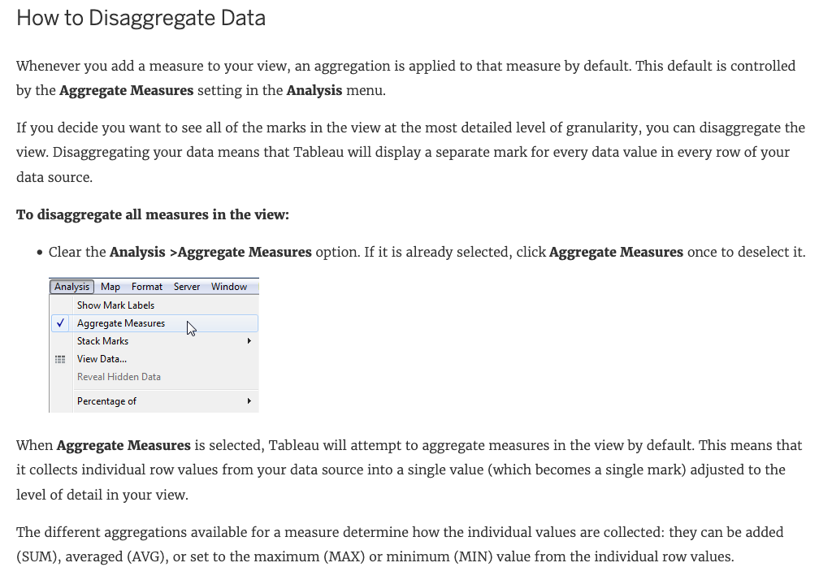

The different aggregations available for a measure determine how the individual values are collected: they can be added (SUM), averaged (AVG), or set to the maximum (MAX) or minimum (MIN) value from the individual row values.

**For a complete list of the available aggregations**, check out - [List of Predefined Aggregations in Tableau](https://help.tableau.com/current/pro/desktop/en-us/calculations_aggregation.htm#AggFuncs).

The level of detail is determined by the **dimensions** in your view—for information about the concept of level of detail, see [How dimensions affect the level of detail in the view](https://help.tableau.com/current/pro/desktop/en-us/datafields_typesandroles.htm#DimLOD).

**Disaggregating your data can be useful for analyzing measures that you may want to use both independently and dependently in the view.**For example, you may be analyzing the results from a product satisfaction survey with the Age of participants along one axis. You can aggregate the Age field to determine the average age of participants or disaggregate the data to determine at what age participants were most satisfied with the product.

**Disaggregating data can be useful when you are viewing data as a scatter plot.** See [Example: Scatter Plots, Aggregation, and Granularity](https://help.tableau.com/current/pro/desktop/en-us/calculations_aggregation.htm#ExampleScatter).

**Reference:** <https://help.tableau.com/current/pro/desktop/en-us/calculations_aggregation.htm>

Bottom of Form

Top of Form

Question 19: **Correct**

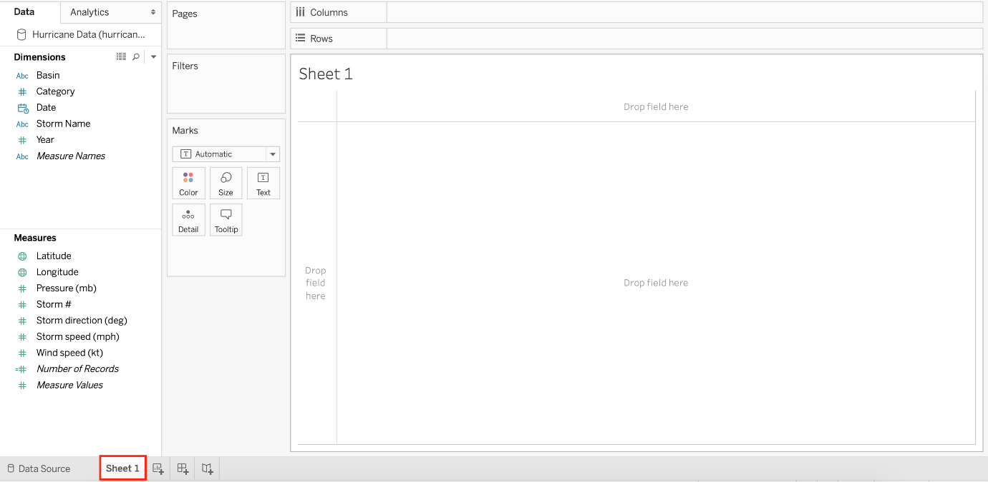

**You clicked Sheet 1 from the data source page, and now you have opened the Tableau Desktop workspace as shown above. What is the main thing that you do here?**

* 

**Clean the data**

* 

**Rename the fields and change data types**

* 

**Preview the data**

* 

**Create visualisations to analyze your data**

**(Correct)**

**Explanation**

The Tableau workspace consists of menus, a toolbar, the Data pane, cards and shelves, and one or more sheets. Sheets can be worksheets, dashboards, or stories. For details on dashboard or story workspaces, see [Create a Dashboard](https://help.tableau.com/current/pro/desktop/en-us/dashboards_create.htm) or [The Story Workspace](https://help.tableau.com/current/pro/desktop/en-us/story_workspace.htm).

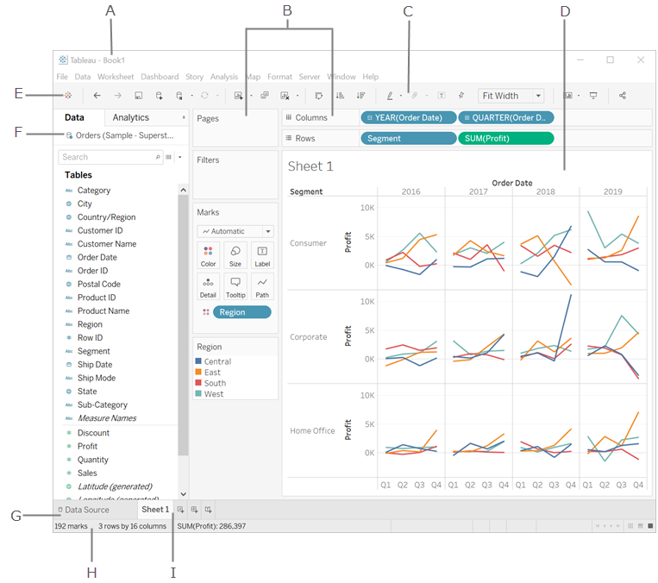

**The main thing you do in the workspace is to create visualisations to analyze your data.**

Renaming data fields, cleaning the data, previewing the data can all be done in the Data source window.

**Reference:**<https://help.tableau.com/current/pro/desktop/en-us/environment_workspace.htm>

Bottom of Form

Top of Form

Question 20: **Correct**

**Which of the following chart type makes use of 'binned' data?**

* 

**Treemaps**

* 

**Histogram**

**(Correct)**

* 

**Gantt Chart**

* 

**Bullet chart**

**Explanation**

A histogram is a chart that displays the shape of a distribution. A histogram looks like a bar chart but groups values for a continuous measure into ranges, or **bins**.

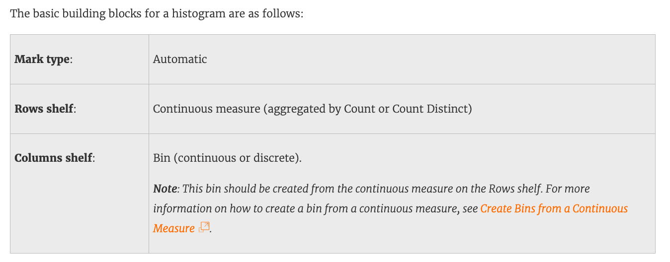

**Reference:**[https://help.tableau.com/current/pro/desktop/en-us/buildexamples_histogram.htm](https://help.tableau.com/current/server/en-us/server_hardware_min.htm)

Bottom of Form

Top of Form

Question 21: **Correct**

**You have cleaned a data source properly, created some calculated fields and renamed some columns. You want to save these changes for future use cases. Which of the following would BEST satisfy this requirement?**

* 

**Save it as a .tds file**

**(Correct)**

* 

**Save it as a .twb file**

* 

**Save it as a .twbx file**

* 

**Save it as a .twm file**

**Explanation**

After making changes to Data, we can save that new data source as a .tds file. To do so, go to data menu on top and then choose your current connected data source. Then next click on Add to Saved Data sources. This will save all calculated fields, changes to fields etc. It will be saved in My Tableau Repository -> Mydatasources. This will then also appear on Tableau Home Page under saved data sources like SampleSuperStore.

**Note:**Data source files do not contain the actual data but rather the information necessary to connect to the actual data as well as any modifications you've made on top of the actual data such as changing default properties, creating calculated fields, adding groups, and so on.

**.twb and .twbx** are not the BEST solutions since the questions nowhere mentions that we need to store our workbooks as well.

**.twm** is a bookmark which contains a single worksheet and are an easy way to quickly share your work.

**Reference:**<https://help.tableau.com/current/pro/desktop/en-us/environ_filesandfolders.htm>

Bottom of Form

Top of Form

Question 22: **Correct**

**Which of the following fields would be best used as Dimensions?**

* 

**Sales**

* 

**Names**

**(Correct)**

* 

**Profit**

* 

**Categories**

**(Correct)**

**Explanation**

Names and Categories would be mostly used as dimensions (categorical data).

Profit and measures contain quantitative data and would be more suitable for Measures!

**Reference:**<https://help.tableau.com/current/pro/desktop/en-us/datafields_typesandroles.htm>

Bottom of Form

Top of Form

Question 23: **Correct**

**By default, measures placed in a view are aggregated. The type of aggregation applied ______________**

* 

**is always COUNT**

* 

**is always AVERAGE**

* 

**depends on the context of the view**

**(Correct)**

* 

**is always sum**

**Explanation**

By default, measures placed in a view are aggregated. Mostly you'll notice that the aggregation is SUM, but not **ALWAYS**.

The type of aggregation applied varies depending on the context of the view.

**Reference:** <https://help.tableau.com/current/pro/desktop/en-us/calculations_aggregation.htm>

Bottom of Form

Top of Form

Question 24: **Correct**

**How would you calculate GDP per capita in Tableau?**

* 

**SUM([Population]/[GDP]])**

* 

**SUM([GDP]*[POPULATION])**

* 

**SUM([GDP]/[POPULATION])**

* 

**SUM([GDP]) / SUM([Population])**

**(Correct)**

**Explanation**

**GDP / Population = GDP Per Capita**

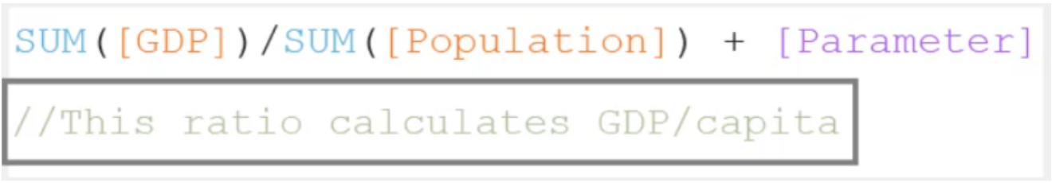

Here Sum is a function, / and + are operators. On the bottom there are comments.

Bottom of Form

Top of Form

Question 25: **Correct**

**True or False: Trend lines can only be used with numeric or date fields**

* 

**False**

* 

**True**

**(Correct)**

**Explanation**

You can show trend lines in a visualization to highlight trends in your data.

To add trend lines to a view, **both axes must** contain a field that can be interpreted as a **number**. For example, you **cannot** add a trend line to a view that has the Product Category dimension, which contains strings, on the Columns shelf and the Profit measure on the Rows shelf.

**However, you can add a trend line to a view of sales over time because both sales and time can be interpreted as numeric values.**

**Reference:** <https://help.tableau.com/current/pro/desktop/en-us/trendlines_add.htm>

Bottom of Form

Top of Form

Question 26: **Correct**

**True or False: The Highlighting action can be disabled for the entire workbook.**

* 

**True**

**(Correct)**

* 

**False**

**Explanation**

Yes, it is possible to disable highlighting for the entire workbook.

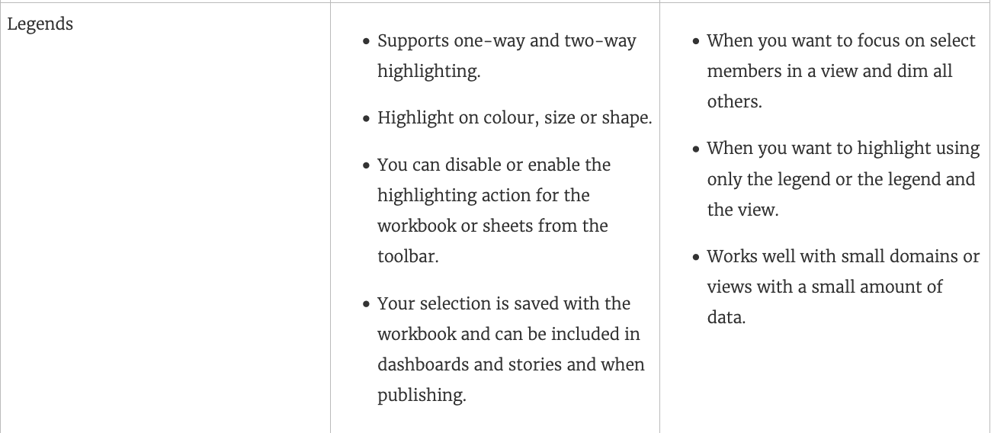

**For more information :**<https://help.tableau.com/current/pro/desktop/en-gb/actions_highlight.htm>

Bottom of Form

Top of Form

Question 27: **Correct**

**In order to avoid any confusions, what should you do after creating a Dual-axis chart?**

* 

**Synchronise the axis**

**(Correct)**

* 

**Edit the labels**

* 

**Change the colours**

* 

**Hide the axis**

**Explanation**

After creating a dual axis chart, make sure to synchronise their axis since they both might not be having the same y-axis.



To align the two axes in a dual axes chart to use the same scale, right-click (control-click on Mac) the secondary axis, and select Synchronize Axis. This aligns the scale of the secondary axis to the scale of the primary axis.

In this example, the **Sales axis is the secondary axis and the Profit axis is the primary axis.**

If you would like to change which axis is the primary, and which axis is the secondary, select the field on the Columns or Rows shelf that is the secondary, and drag it in front of the primary field on the shelf until you see an orange triangle appear.

In this example, you can select the SUM(Sales) field on the Rows shelf, and drag it in front of the SUM(Profit) field. The Sales axis is now the primary and the Profit axis is the secondary.

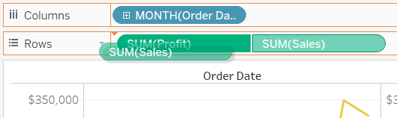

**Reference:** <https://help.tableau.com/current/pro/desktop/en-us/multiple_measures.htm>

Bottom of Form

Top of Form

Question 28: **Correct**

**The default path for all supporting files, data sources, icons, logs etc is in ______________________**

* 

**Documents -> Tableau**

* 

**Downloads -> Tableau Support Files**

* 

**Documents -> Tableau Files**

* 

**Documents -> My Tableau Repository**

**(Correct)**

**Explanation**

**By default, all of the above mentioned are stored in Documents -> My Tableau Repository**

**Reference:** <https://help.tableau.com/current/pro/desktop/en-us/environ_filesandfolders.htm>

Bottom of Form

Top of Form

Question 29: **Correct**

**True or False: All rows from both tables are returned in an INNER JOIN**

* 

**False**

**(Correct)**

* 

**True**

**Explanation**

The INNER JOIN keyword selects all rows from **both tables** as long as there is a match between the columns. Consider 2 tables "Orders" and "Customers".

If there are records in the "Orders" table that **do not** have matches in "Customers", these orders will **not be shown!**

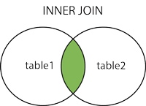

**Reference:**<https://www.w3schools.com/sql/sql_join_inner.asp>

Bottom of Form

Top of Form

Question 30: **Correct**

_______________ enables us to create workbooks and views, dashboards, and data sources in Tableau Desktop, and then publish this content to our own server.

* 

**Tableau myServer**

* 

**Tableau Prep**

* 

**Tableau Server**

**(Correct)**

* 

**Tableau Public**

**Explanation**

Tableau **SERVER** enables us to create workbooks and views, dashboards, and data sources in Tableau Desktop, and then publish this content to our **own** server.

Moreover, as a Tableau Server **administrator** you will control who has access to server content to help protect sensitive data. Administrators can set user permissions on projects, workbooks, views, and data sources.

**Reference:**<https://www.tableau.com/learn/webinars/introduction-tableau-server>

Bottom of Form

Top of Form

Question 31: **Correct**

**By default, what does Tableau do when you connect to a data source?**

* 

**Creates a live connection to the data**

**(Correct)**

* 

**Sorts the data in descending order**

* 

**Loads your actual file into Tableau**

* 

**Creates an extract of the data**

**Explanation**

Before you can build a view and analyze your data, you must first **connect** Tableau to your data. Tableau supports connecting to a wide variety of data, stored in a variety of places.

**By default, when you connect a data source to Tableau, Tableau will create a live connection to the data.**

Live connection refers to a data source that contains direct connection to underlying data, which provides real-time or near real-time data. With a live connection, Tableau makes queries directly against the database or other source, and returns the results of the query for use in a workbook. Users can create live connections and then share them on Tableau Server so that other Tableau users can use the same data using the same connection and filtering settings.

**Reference:** <https://help.tableau.com/current/guides/everybody-install/en-us/everybody_admin_data.htm>

Bottom of Form

Top of Form

Question 32: **Correct**

**Is it possible to use measures in the same view multiple times (e.g. SUM of the measure and AVG of the measure)?**

* 

**No**

* 

**Yes**

**(Correct)**

**Explanation**

Yes, it is very much possible to use measures in the same view multiple times. For example, refer to the image below:

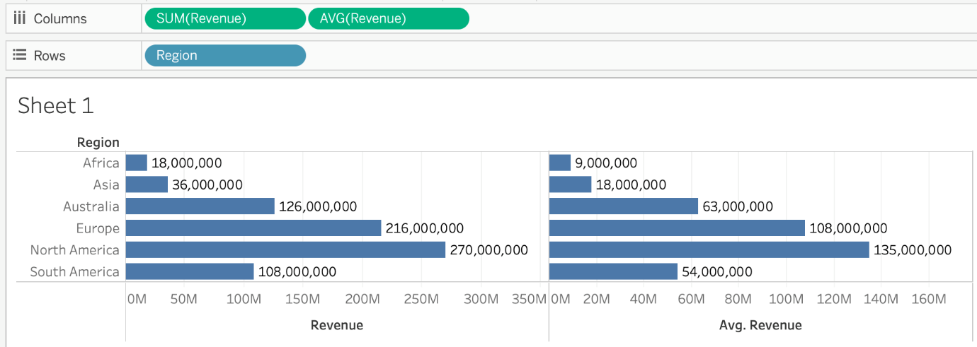

We are using **BOTH** the **Sum** of the revenue and the **AVG** of the revenue in the same view!

Bottom of Form

Top of Form

Question 33: **Correct**

**Which of the following are compelling reasons to use a Stacked Bar Chart?**

* 

**To visualize each discrete category using a separate bar.**

* 

**To be able to visualize complex information with fewer bars / marks**

**(Correct)**

* 

**To visualize parts of a whole**

**(Correct)**

* 

**To easily visualize trends over time**

**Explanation**

Stacked bar charts will usually have lesser number of bars compared to a normal bar chart:

**Normal bar chart - 9 bars**

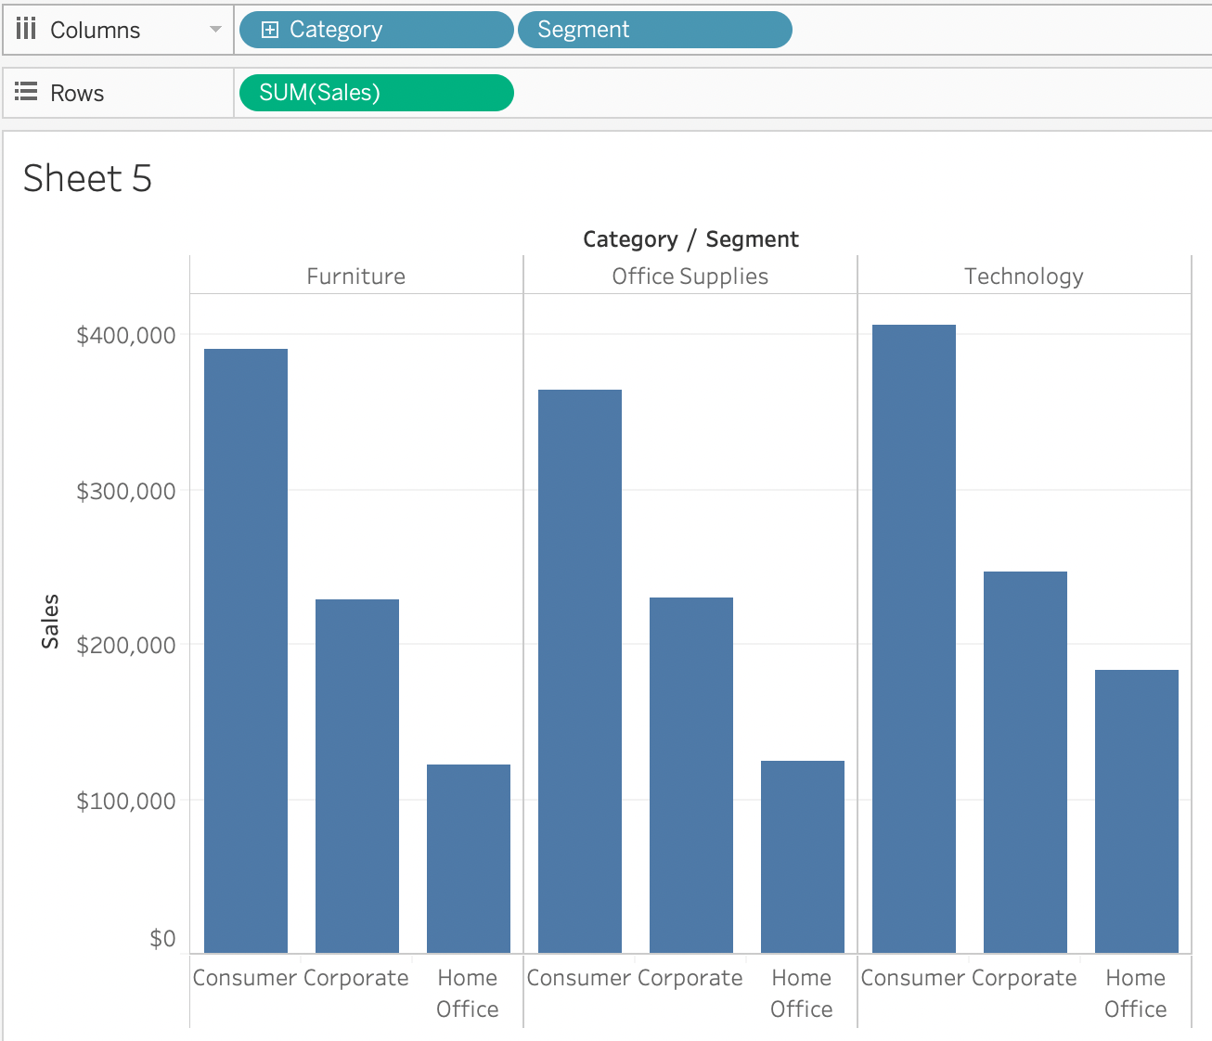

**Stacked Bar Chart - 3 bars**

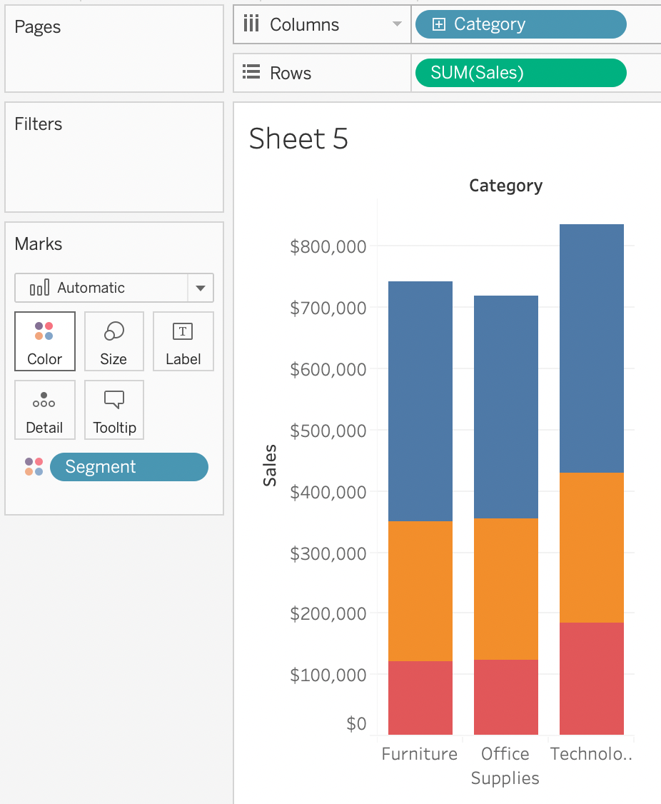

We can easily see a 'part-of-a-whole' methodology being used here as well - we are seeing the breakdown of Segments within each Category.

**To easily visualize trends over time -** This is the definition of a line chart.

**To visualize each discrete category using a separate bar -**This can be accomplished using a simple bar chart, why use a stacked one?

Bottom of Form

Top of Form

Question 34: **Correct**

**True or False : Bins can be created on dimensions**

* 

**False**

* 

**True**

**(Correct)**

**Explanation**

Tricky question!

Bin are a user-defined grouping of **numerical data** in the data source.

According to the official Tableau documentation: It's  sometimes useful to convert a continuous measure **(or a numeric dimension)** into bins.

Have a look at the following image. When we right click a measure, we get the following options:

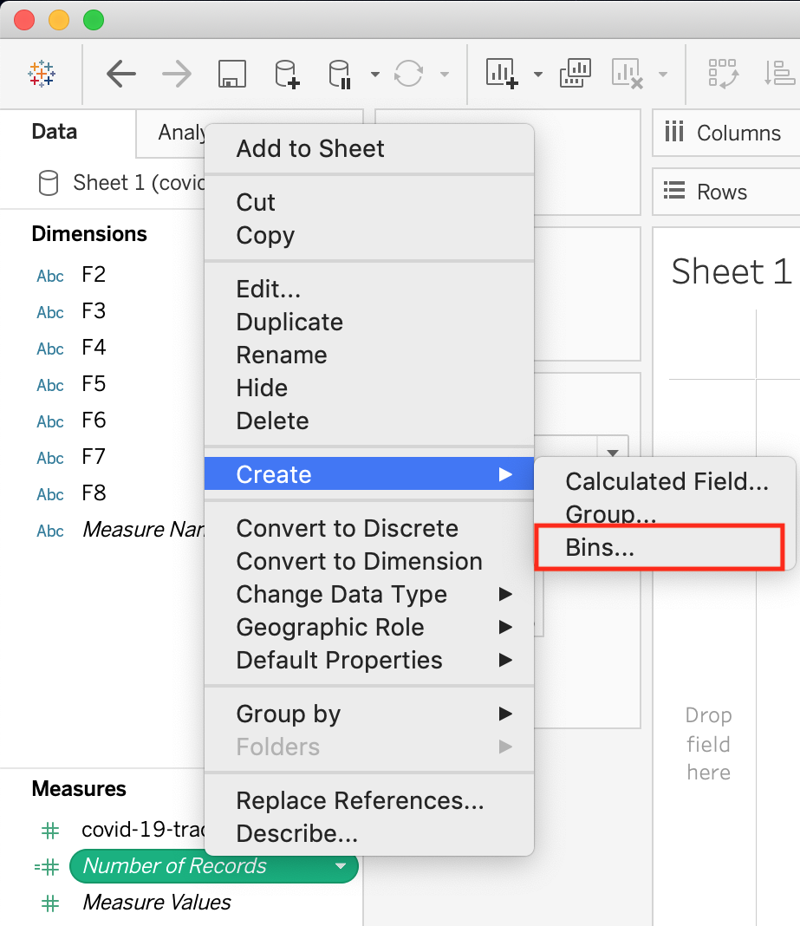

However, for a dimension (this is because the **DATA TYPE** of this dimension is a string:

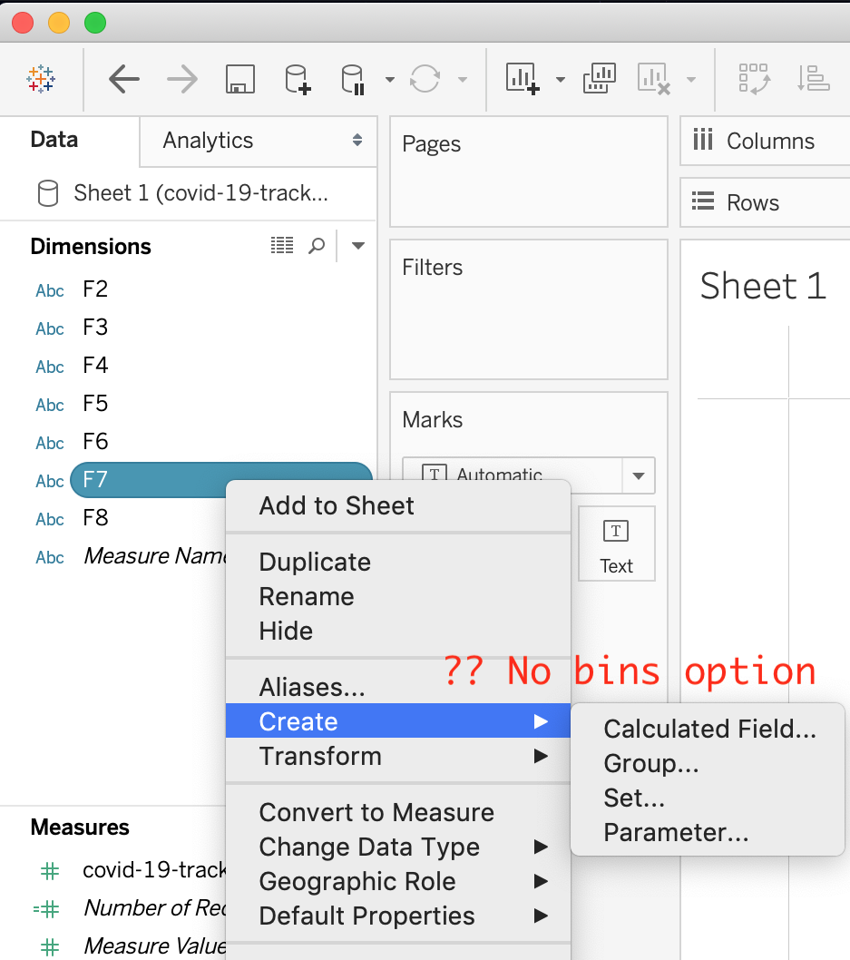

But what if we have a dimension of type **NUMBER (NUMERIC DIMENSION)**? See below:

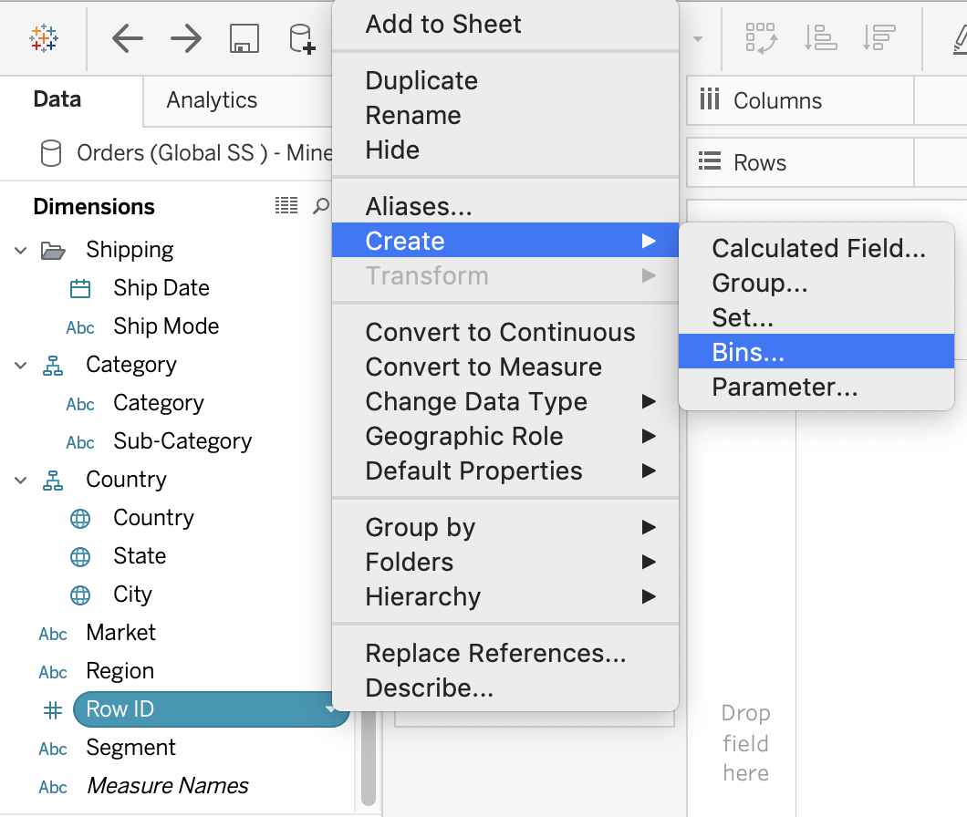

We can clearly create bins from dimensions too - they just have to be numeric :)

For more information, please refer to : <https://help.tableau.com/current/pro/desktop/en-us/calculations_bins.htm>

Bottom of Form

Top of Form

Question 35: **Correct**

**When you drop a continuous field on Color, Tableau displays a quantitative legend with a ___________ range of colors.**

* 

**Mixed**

* 

**Discrete**

* 

**Fading**

* 

**Continuous**

**(Correct)**

**Explanation**

When you drop a discrete field on Color in the Marks card, Tableau displays a **categorical** palette and assigns a color to each value of the field.

When you drop a continuous field on Color, Tableau displays a quantitative legend with a **continuous** range of colors.

**Web version:**

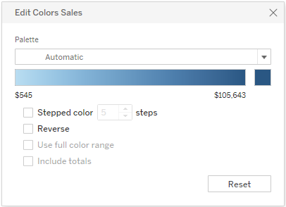

**Desktop Version:**

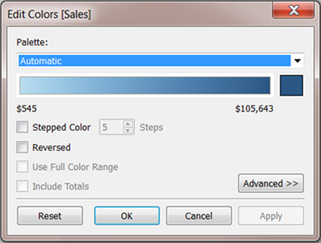

For more information about color palettes, see [Color Palettes and Effects](https://help.tableau.com/current/pro/desktop/en-us/viewparts_marks_markproperties_color.htm).

Bottom of Form

Top of Form

Question 36: **Correct**

**If you use a percent difference Quick Table Calculation, what value will be the first data value?**

* 

**-1**

* 

**null**

**(Correct)**

* 

**0000**

* 

**0**

**Explanation**

When using a Percent difference, Tableau calculates what the percent change has occured as compared to the last data value. **BUT, for the first data value, there is no previous value to compare it to. Hence, it appears as NULL.**

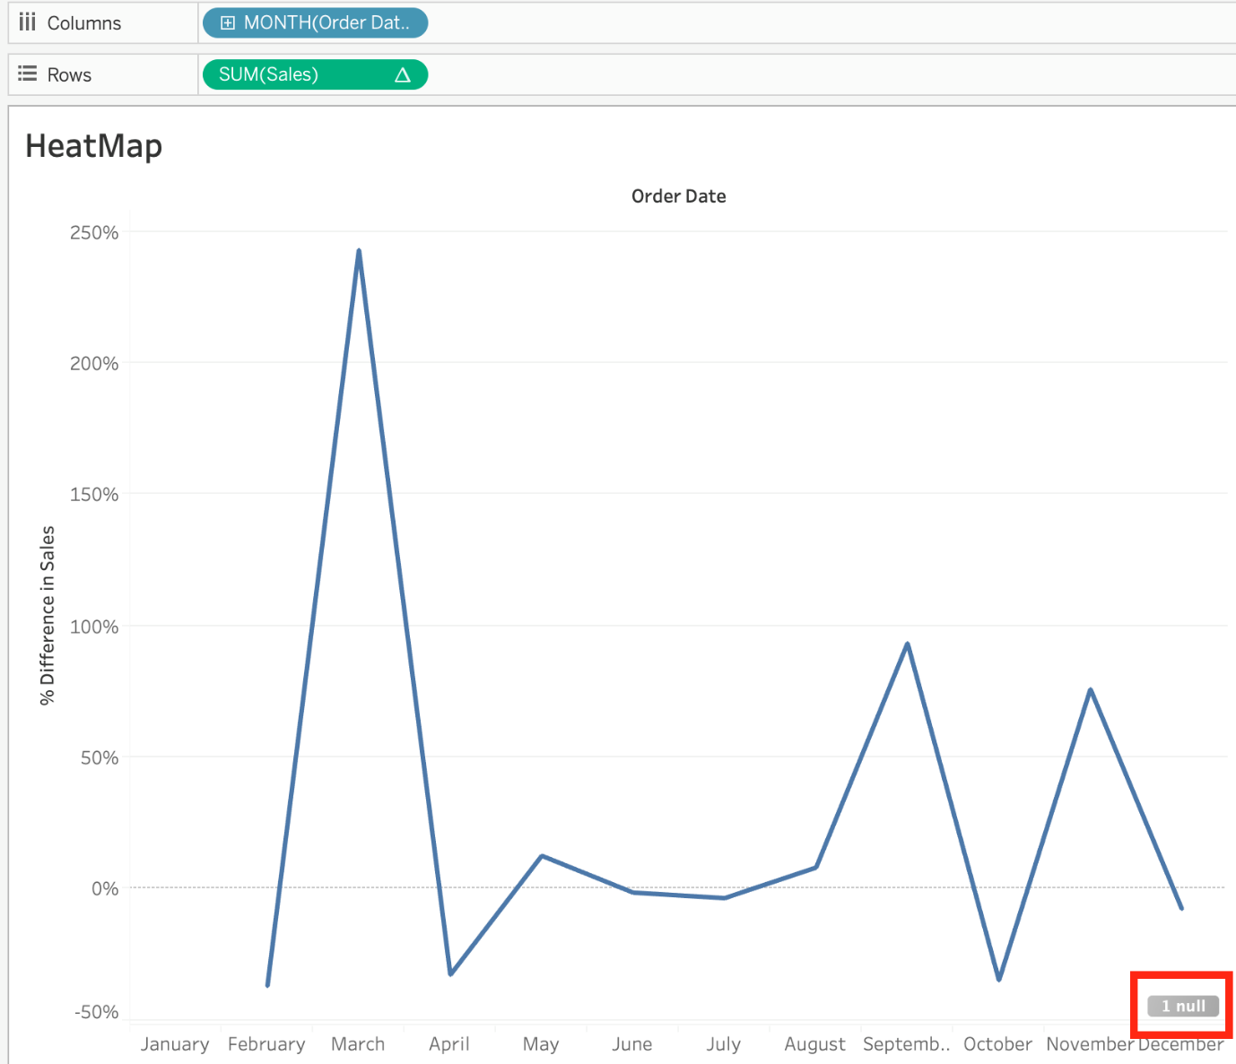

Bottom of Form

Top of Form

Question 37: **Correct**

**Which of the following represent a valid method to create a Bullet Graph with the LEAST number of fields possible?**

* 

**Using 2 dimensions and 3 measures**

* 

**Using 2 measures**

**(Correct)**

* 

**Using 1 measure**

* 

**Using 2 dimensions**

**Explanation**

A bullet graph is a variation of a bar graph developed to replace dashboard gauges and meters. A bullet graph is useful for comparing the performance of a primary measure to one or more other measures. Below is a single bullet graph showing how actual sales compared to estimated sales.

We can create a Bullet graph with **just 2 measures!**This method requires the **LEAST** number of fields possible to create this type of chart.

The **best way** to tackle such questions in the exam is to click the **"SHOW ME"** button on top right, and hover over the chart we want to create.

In our case, it is a Bullet graph.

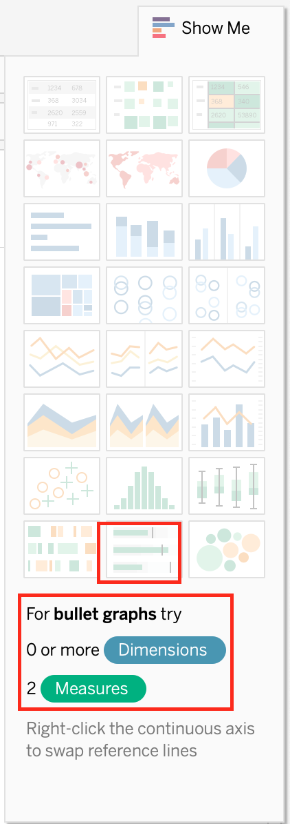



Therefore, we need 2 measures at least to create this chart, and 0 or more dimensions.

**Reference:**<https://help.tableau.com/current/pro/desktop/en-us/qs_bullet_graphs.htm>

Bottom of Form

Top of Form

Question 38: **Correct**

**For Bullet Graphs we need at least ____________ measures**

* 

**2**

**(Correct)**

* 

**3**

* 

**4**

* 

**1**

**Explanation**

A bullet graph is a variation of a bar graph developed to replace dashboard gauges and meters. A bullet graph is useful for comparing the performance of a **primary measure to one or more other measures.**

Therefore, we need at least 2 measures for creating bullet graphs.



**Reference:** <https://help.tableau.com/current/pro/desktop/en-us/qs_bullet_graphs.htm>

Bottom of Form

Top of Form

Question 39: **Correct**

**Which of the following are benefits of using Data Extracts in Tableau?**

* 

**Faster to work with**

**(Correct)**

* 

**Improved Performance**

**(Correct)**

* 

**Ability to use the data offline**

**(Correct)**

* 

**Working with freshest data at all times**

**Explanation**

Extracts are advantageous for several reasons:

**1) Supports large data sets:** You can create extracts that contain billions of rows of data.

**2) Fast to create:** If you're working with large data sets, creating and working with extracts can be faster than working with the original data.

**3) Help improve performance:** When you interact with views that use extract data sources, you generally experience better performance than when interacting with views based on connections to the original data.

**4) Support additional functionality:** Extracts allow you to take advantage of Tableau functionality that's not available or supported by the original data, such as the ability to compute Count Distinct.

**5) Provide offline access to your data:** Extracts allow you to save and work with the data locally when the original data is not available. For example, when you are traveling.

To work with the MOST up-do-date data, use a live connection instead!

**Reference:**<https://help.tableau.com/current/pro/desktop/en-us/extracting_data.htm>

Bottom of Form

Top of Form

Question 40: **Correct**

**Which of the following are stored in a .tds file? Choose 3.**

* 

**Data Connection information**

**(Correct)**

* 

**Data Extracts**

* 

**Metadata edits**

**(Correct)**

* 

**Calculated Fields**

**(Correct)**

* 

**Visualizations**

**Explanation**

If you’ve created a data connection that you might want to use with other workbooks or share with colleagues, you can export (save) the data source to a file. You might want to do this also if you’ve added joined tables, default properties, or custom fields—such as groups, sets, calculated fields, and binned fields—to the Data pane.

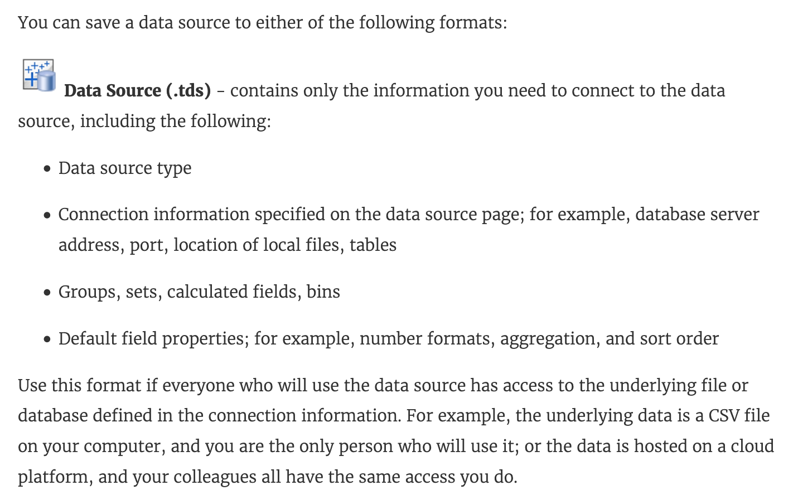

**Visualisations and Data extracts are NOT saved in a .tds file!**

**Reference:**<https://help.tableau.com/current/pro/desktop/en-us/export_connection.htm>

Bottom of Form

Top of Form

Question 41: **Correct**

**______________  refers to the level of detail for a piece of data, wherever you are looking.**

* 

**Data Cleanliness**

* 

**Data connectivity**

* 

**Data granularity**

**(Correct)**

* 

**Data LOD**

**Explanation**

Data is generated and analyzed at many different levels of granularity. Granularity is the level of detail of the data. For example, when looking at graduation data, granularity would describe whether a row in the data set represents a single person or the graduating class of a university.

**Reference:**<https://www.tableau.com/about/blog/2018/6/data-prep-101-what-aggregate-function-and-how-do-you-combine-aggregated-data-89244>

Bottom of Form

Top of Form

Question 42: **Correct**

By definition, Tableau displays measures over time as a ____________

* 

**Line**

**(Correct)**

* 

**Bar**

* 

**Stacked Bar**

* 

**Packed Bubble**

**Explanation**

Line charts connect individual data points in a view. They provide a simple way to visualize a sequence of values and are useful when you want to see trends over time, or to forecast future values.

Please refer to the images below:

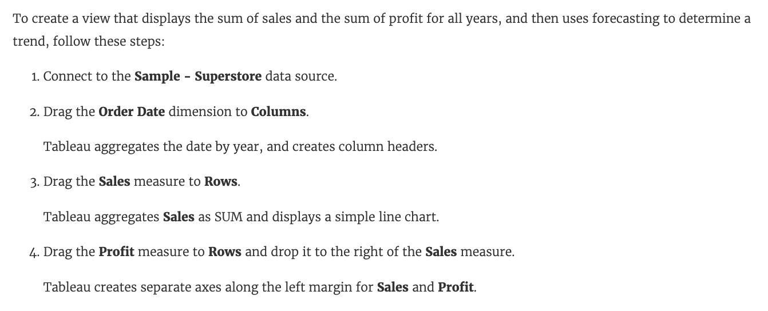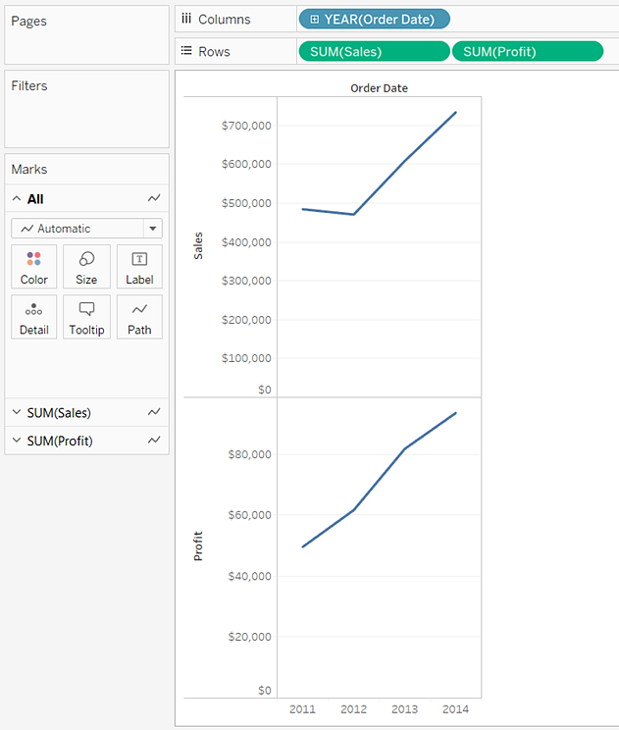

**Reference:**<https://help.tableau.com/current/pro/desktop/en-us/buildexamples_line.htm>

Bottom of Form

Top of Form

Question 43: **Correct**

**Which of the following is true about 'Incremental refresh' when creating Extracts in Tableau?**

* 

**It replaces all of the contents in the extract**

* 

**There is no difference, both are the same when using extracts. They are different when using live connections.**

* 

**It only adds rows that are new since the previous refresh.**

**(Correct)**

* 

**They can only be used with large datasets**

**Explanation**

**Imp question!**

Extracts are saved subsets of data that you can use to improve performance or to take advantage of Tableau functionality not available or supported in your original data. When you create an extract of your data, you can reduce the total amount of data by using filters and configuring other limits. After you create an extract, you can refresh it with data from the original data.

**When refreshing the data, you have the option to either do a full refresh, which replaces all of the contents in the extract, or you can do an incremental refresh, which only adds rows that are new since the previous refresh.**

**Reference:**<https://help.tableau.com/current/pro/desktop/en-us/extracting_data.htm>

Bottom of Form

Top of Form

Question 44: **Correct**

**Which of the following can you use to create a Histogram?**

* 

**2 dimensions**

* 

**1 dimension**

* 

**2 measures**

* 

**1 measure**

**(Correct)**

**Explanation**

A histogram is a chart that displays the **shape** of a distribution. A histogram looks like a bar chart but groups values for a **continuous measure** into ranges, or bins.

The basic building blocks for a histogram are as follows:

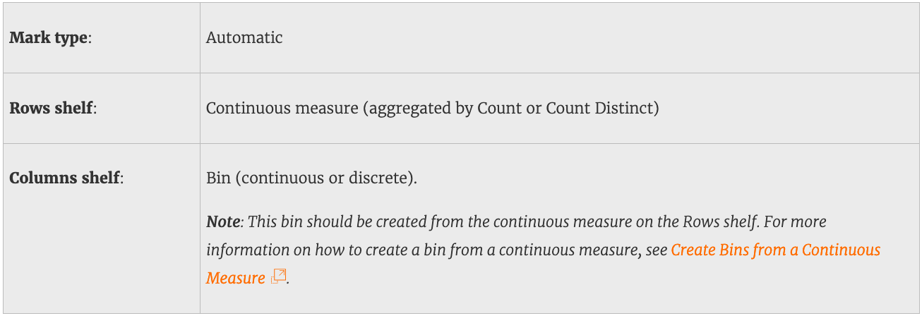

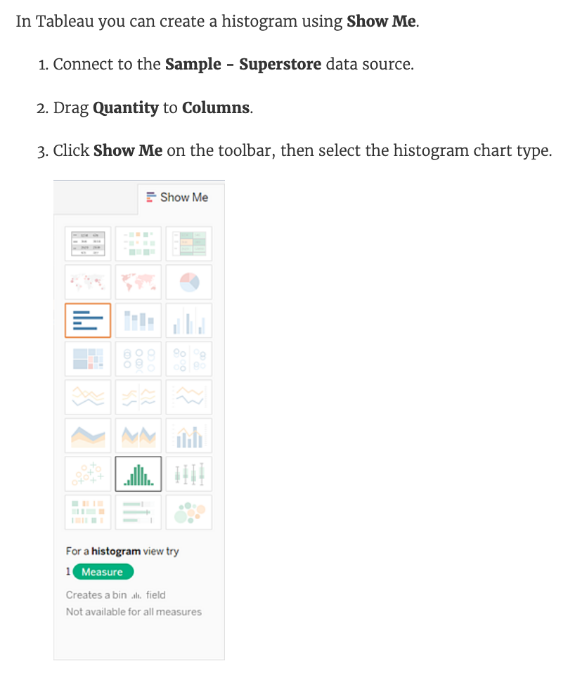

**Demo :**



**Reference:** <https://help.tableau.com/current/pro/desktop/en-us/buildexamples_histogram.htm>

Bottom of Form

Top of Form

Question 45: **Correct**

**Which of the following would you use to connect to multiple tables in a single data source at once?**

* 

**A Blend**

* 

**A Set**

* 

**A Hierarchy**

* 

**A Join**

**(Correct)**

**Explanation**

The data that you analyze in Tableau is often made up of a collection of tables that are related by specific fields (that is, **columns**). Joining is a method for combining data on based on those common fields. The result of combining data using a join is a virtual table that is typically **extended** horizontally by adding columns of data.

For example, consider the following two tables originating from a single data source:

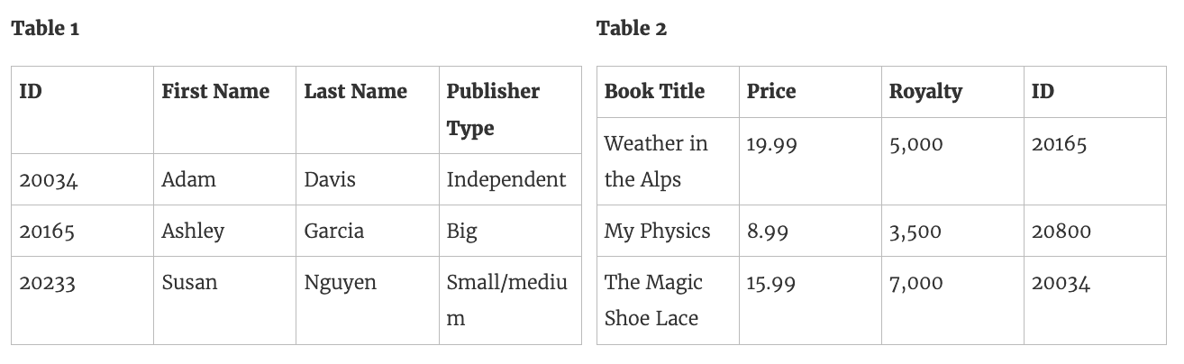

We can combine these 2 tables, simply by joining the tables on ID to answer questions like, "How much was paid in royalties for authors from a given publisher?". By combining tables using a join, you can view and use related data from different tables in your analysis.

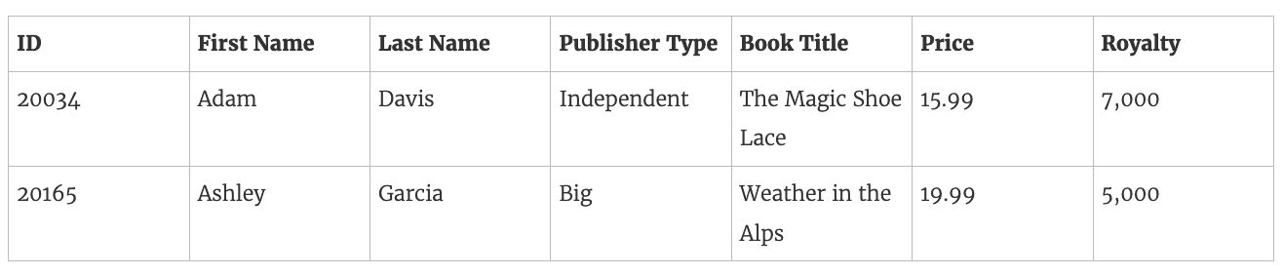

**Reference:**<https://help.tableau.com/current/pro/desktop/en-us/joining_tables.htm>

Bottom of Form